

American International University-Bangladesh (AIUB) Department of Computer Science
Faculty of Science & Technology (FST)

Stay Finder: A complete Travel Stay Platform
Semester: Spring 25-26

Table of Contents

- Project Proposal............................................................................................................................ 02
  - Background to the Problem ......................................................................................... 02
  - Selection of Process Model ......................................................................................... 03
- Timeline Chart / Gantt Chart ………………………….………………………………………………………………...04
- PRD ............................................................................................................................................. 06
  - Functional Requirements ............................................................................................ 07
  - Non-Functional Requirements ..................................................................................... 28
- Software Design .......................................................................................................................... 37
  - System Deisgn ..................................................................................................................... 37
  - UI Deisgn using Figma ........................................................................................................ 39
- Git Workflow .............................................................................................................................. 57
- Software Testing ......................................................................................................................... 61
- Conclusion ................................................................................................................................... 98

1. PROJECT PROPOSAL

1.1 Background to the Problem
Finding, booking, and managing accommodations can often be complicated for both travelers and property owners. Customers face challenges such as unclear availability, inconsistent pricing, and a lack of trustworthy reviews. On the other hand, property owners struggle to manage multiple listings, track reservations, handle payments securely, and respond to customer feedback.
Existing platforms like Airbnb have shown the demand for short-term rental solutions, but many local businesses and independent hosts still lack a reliable system tailored to their needs. Without a centralized platform, miscommunication, booking errors, and missed business opportunities are common. StayFinder is a web-based software designed to bridge the gap between travelers and property owners by providing a centralized, secure, and intuitive platform for finding, booking, and managing accommodations.
Target Group of Users: The system is designed for multiple groups of users:
- Customers (Travelers): Individuals looking for affordable, comfortable, and reliable places to stay, with easy booking and secure payments.
- Hosts (Property Owners): People or businesses renting out houses, apartments, or hotels who need tools to manage listings, availability, pricing, and earnings.
- Super Admin (Platform Owner): The system administrator who oversees platform operations, ensures quality control, manages users and properties, and earns commission from bookings.

1.2 Selection of Process Model
Process Model Explanation The suitable model for our project is Scrum. Scrum is an Agile software development process model that follows an iterative and incremental approach. The development work is divided into fixed time periods called Sprints, where each Sprint delivers a working product increment. Scrum is adaptive in nature and supports frequent feedback, continuous improvement, and effective collaboration among team members.

Roles and Responsibilities
- Scrum Master: Ensures Scrum rules are followed, facilitates the process, and removes obstacles.
- Product Owner: Manages and prioritizes the Product Backlog, makes final decisions on requirements.
- Scrum Team: Self-organizing developers who estimate, plan, and deliver increments each sprint.
- Customer: Provides input on backlog items and reviews increments to ensure needs are met.
- Management: Sets goals, provides resources, and supports standards and decision-making.

Scrum Practices
- Product Backlog: A prioritized list of all system requirements, features, and improvements.
- Sprint: A fixed-duration development cycle in which selected backlog items are implemented and delivered as a working product increment.
- Sprint Planning Meeting: A meeting held at the beginning of each Sprint to define Sprint goals and select Product Backlog items for implementation.
- Daily Scrum Meeting: A short daily meeting to track progress, discuss completed work, identify upcoming tasks, and resolve blockers.
- Sprint Review Meeting: A meeting conducted at the end of each Sprint to demonstrate the completed product increment and collect stakeholder feedback.
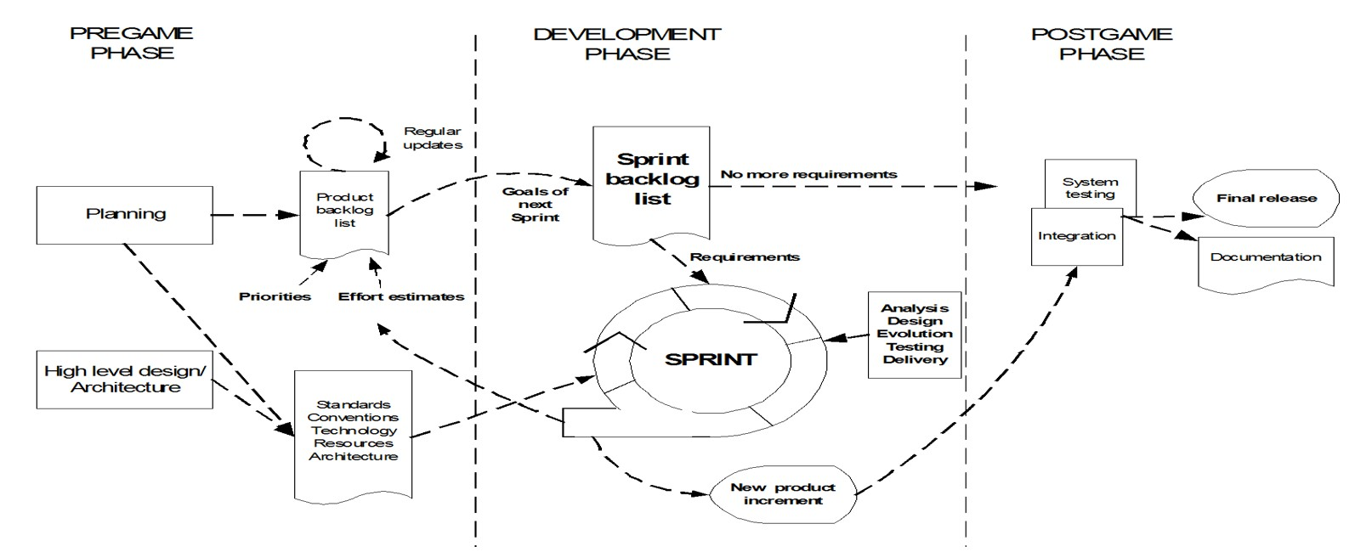
Why We Chose Scrum: We chose the Scrum process model for our project because it offers flexibility and is well suited for building a complex, evolving system. StayFinder has multiple modules (Customer, Host, Admin, Payment). Scrum allows each to be developed and tested in short cycles. Its iterative approach ensures that we can deliver working parts of the system step by step, reducing risks and enabling early problem detection. Scrum's structured practices make it easier to manage changing requirements (e.g., new filters or payment options) without disrupting overall progress.

2. Timeline Chart / Gantt Chart
- Final Suggestion
Metric | Value
Project Type | Semi-Detached
SLOC | 35,000
KLOC | 35

- COCOMO Calculation
  - PM Formula
PM=3.0×(35)1.12PM = 3.0 \times (35)^{1.12}PM=3.0×(35)1.12
  - Development Time
TDEV=2.5×(PM)0.35TDEV = 2.5 \times (PM)^{0.35}TDEV=2.5×(PM)0.35

2.3 Team Size
ST=PMTDEVST = \frac{PM}{TDEV}ST=TDEVPM

3. Final COCOMO Result
Parameter |  | Value
PM | 160 Person-Month
Development Time | 15 Months
Team Size | 11 Members

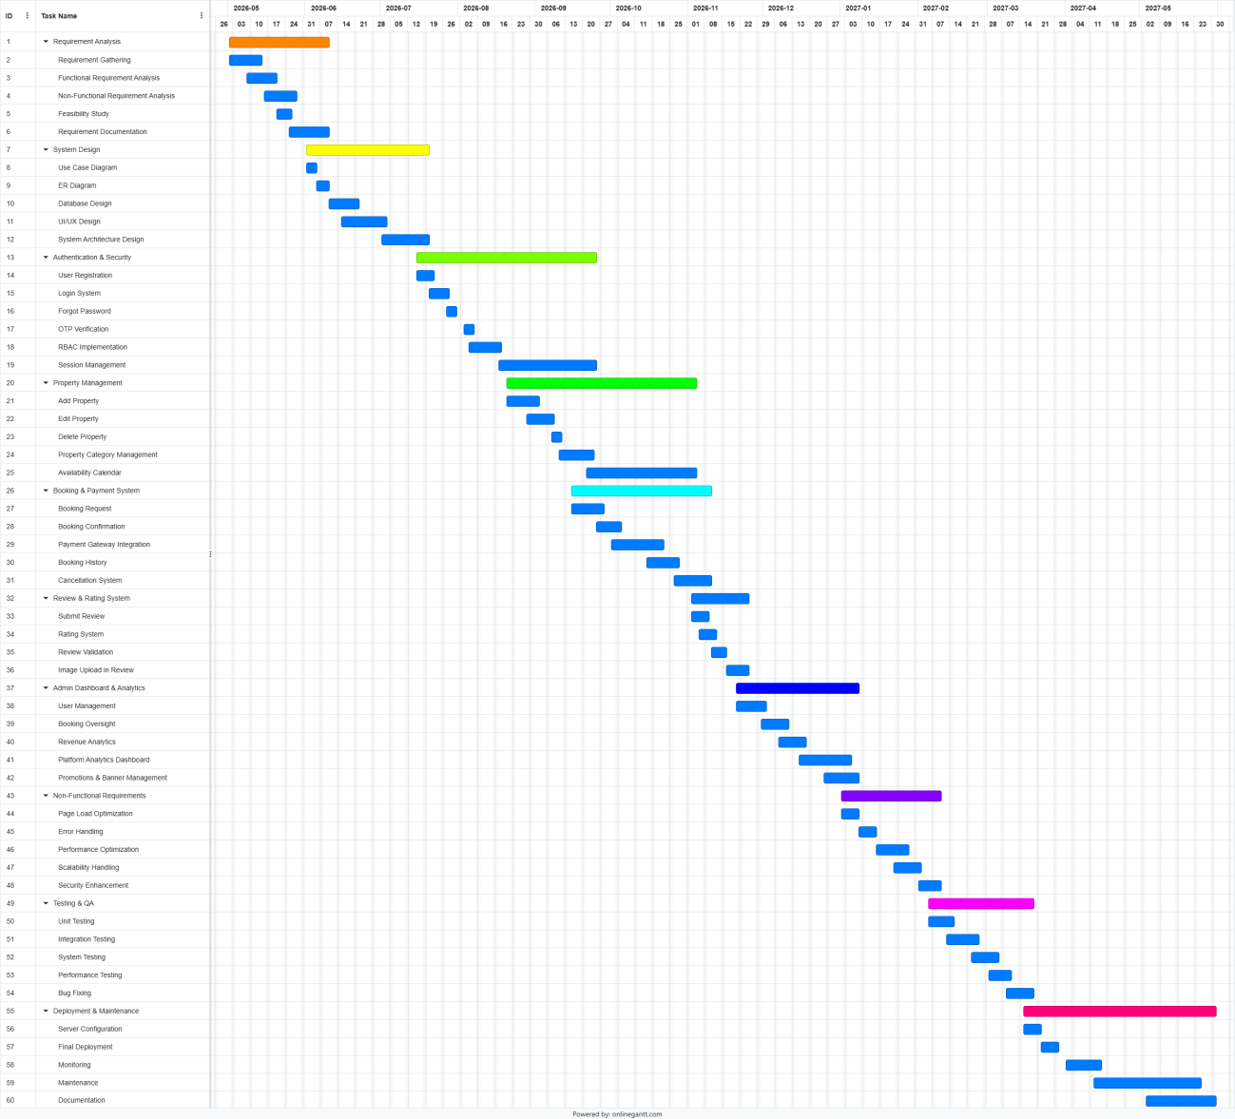

3. REQUIREMENTS DOCUMENT (PRD)
Product Requirement Document (PRD)
StayFinder: A Complete Travel Stay Platform

Client: American International University-Bangladesh (AIUB) – Dept. of Computer Science
Product Type: Web Application
Domain: Travel & Hospitality / Property Rental
Access Layers: Customer, Host, Super Admin
Design Required: Yes – Figma Prototype
Development Phase: Scrum (5 Sprints)
Goals & Objectives: StayFinder aims to bridge the gap between travelers and property owners by providing a centralized, secure, and intuitive platform for finding, booking, and managing accommodations. User roles: Customer (Traveler) – Search, book, and pay for properties; leave reviews. Host (Property Owner) – List properties, manage bookings, track earnings. Super Admin – Oversee platform, approve listings, manage users, track commission.
Functional Requirements
Phase | Ite m  No | Specification [Role] | Screen Definition | User Story | Acceptance Criteria
Feature 1: Authentication & Profile Management
Phase 1 | 1 | The system should allow customers to register for a new account [Customer] | Header: Platform logo + navigation Content:  - Registration form for customers  - Fields: Full Name, Email,  Username, Password,  Confirm Password, Phone  Number, Address  - OTP/Email verification option  CTA: “Register” button  Footer: Terms &  Conditions, Privacy Policy | As a user, I want to register as a customer so that I can create an account and access the platform services. | - Full name, email, username, phone, DOB, address, postcode, city, and division should be required.  - Email (input) field should only accept a valid and unique email address. Otherwise, the system should show an 'invalid or already used email' message.  - Password (input) should be minimum 8 characters long.  - Confirm password (input) should match password. Otherwise, the system should show a 'password do not match' message.  - OTP should be sent to phone number for verification.

- A confirmation email should be sent after successful registration.
- On clicking register button, customer information should be stored in database and user should be redirected to customer dashboard.
Phase 1 | 2 | The system should allow hosts to register for a new account [Host] | Header: Platform logo + navigation Content:  - Registration form for hosts  - Fields: Full  Name/Business Name,  Email, Username,  Password, Confirm  Password, Phone Number,  Business Address  - Option for uploading property/business details (optional at this stage)  - OTP/Email verification step  CTA: “Register as Host” button  Footer: Terms &  Conditions, Privacy Policy links | As a property owner (host), I want to register on the platform so that I can list and manage my properties and start receiving bookings. | - The system should require all mandatory fields before allowing submission  - The system should verify the user’s email/phone using OTP  - The system should enforce password rules (minimum length, special characters, etc.)  - The system should display a success message after successful registration  - The system should redirect the user to the host dashboard after registration  - The system should show appropriate error messages for invalid or duplicate inputs
Phase 1 | 3 | The system should allow users to sign in to their accounts [Customer/Host] | Header: Platform logo + navigation Content:  Sign in form for customers and hosts | As a user, I want to sign in securely so that I can access my account and dashboard. | - Email and password should match database records.  - On successful signin, user should be redirected to the appropriate

 |  |  | Fields:  - Email  - Password - Remember Me Options:  - Google Sign In  - Forgot Password  CTA: Sign In  Footer: Terms &  Conditions, Privacy Policy links |  | dashboard (customer / host).  - If credentials do not match, the system should show 'Invalid email or password' message.  - Google sign-in option should be available.  - Remember me option should store session cookie for 30 days.
Phase 1 | 4 | The system should allow admin users to sign in to their accounts [Admin] | Header: Platform logo + admin portal title Content:  Admin sign in form Fields:  - Admin Email  - Password Options:  - Forgot Password  CTA: Sign In  Footer: Security notice /  Privacy Policy | As a user, I want to sign in as an admin so that I can access the admin dashboard and manage platform operations. | - Email (input) field should end with  \@stayfinder.com.  Otherwise, the system should show 'Invalid admin email' message.  - Password (input) should match database record.  - On successful signin, user should be redirected to admin dashboard.  - Failed login attempts after 5 tries should lock the account for 15 minutes.
Phase 1 | 5 | The system should allow users to reset their password if | Header: Platform logo + navigation | As a user, I want to reset my password | - Email (input) field should exist in database. Otherwise, the system

 |  | they forget it  [Customer/Host/Ad min] | Content:  Password recovery form Fields:  - Email  - OTP  - New Password - Confirm Password CTA:  - Send OTP  - Reset Password  Footer: Back to Sign In link | so that I can regain access to my account if I forget my login credentials. | should show 'No account found' message.  - OTP should be sent to registered email address and it should remain valid for 10 minutes.  - New password (input) should be minimum 8 characters long and should contain at least one special character.  - Confirm password (input) should match new password. Otherwise, the system should show 'password do not match' message.  - On successful password reset, system should show 'Password reset successful' message and user should be redirected to sign in page.
Phase 1 | 6 | The system should allow users to view and edit their profile information [Customer/Host] | Header: Platform logo + user navigation Content:  Profile page with editable form  Fields:  - Full Name  - Email  - Phone  - Date of Birth  - Address  - Profile Photo  - Change Password Section | As a user, I want to view and edit my profile information so that I can keep my account details updated. | - All existing profile fields should be pre-filled in edit form.  - Email format should be validated and phone number should be 11 digits.  - On clicking save, success notification should be shown and profile page should be refreshed.  - Change photo should accept PNG/JPG only and maximum file size should be 2MB.  - For password change, old password should be verified and new password should be

 |  |  | CTA:  - Save Changes  - Update Photo  - Change Password |  | minimum 8 characters long.
Feature 2: Property Management
Phase 2 | 7 | The system should allow hosts to add new property listings  [Host] | Header: Host dashboard + navigation Content:  Property listing creation form  Fields:  - Property Title  - Description  - Property Type  - Category  - Price Per Night  - Location  - Photos  - Amenities  - Availability  CTA: Submit Listing  Footer: Listing guidelines / help link | As a user, I want to add a property listing so that customers can view and book my property. | - All required fields (title, location, price, type, category) should be filled.  - Minimum 1 photo should be required and each photo size should be maximum 5MB.  - Price should be a positive number.  - Property should be saved with 'Pending Approval' status.  - Host should receive notification when admin approves or rejects the property.  - Listing should be visible on platform only after admin approval.

Phase 2 | 8 | The system should allow hosts to edit or remove their property listings  [Host] | Header: Host dashboard + navigation Content:  Property management page Sections:  - Existing Listings Table  - Edit Listing Form - Remove Listing Action Fields:  - Title  - Description  - Type  - Category  - Price  - Location  - Photos - Amenities CTA:  - Save Changes  - Remove Listing | As a user, I want to edit or remove my  property listing so that I can keep my property information accurate and updated. | - Edit form should be pre-filled with existing data.  - Any edited listing should return to 'Pending Approval' status.  - Remove action should require confirmation dialog.  - Removed listing should disappear from customer search immediately.  - Host should be able to view all listings with status (active / pending / rejected).
Phase 2 | 9 | The system should allow administrators to approve or reject property listings  [Admin] | Header: Admin dashboard + navigation Content:  Pending listings review page  Sections: | As a user, I want to review submitted property listings so that only valid and approved listings appear on the platform. | - Pending listings table should show all submissions awaiting review.  - On approving a listing, listing status should change to 'Active' and host should be notified by email.

 |  |  | - Pending Listings Table  - Listing Details Preview  - Approval / Rejection  Controls Fields:  - Listing Information  - Host Information - Rejection Reason CTA:  - Approve  - Reject  - Filter by Status / Date / Category |  | - On rejecting a listing, admin should enter rejection reason and host should be notified with the reason.  - Approved listings should immediately appear in customer search.  - Admin should be able  to filter listings by status, date, and category.
Phase 2 | 10 | The system should allow administrators to manage property categories and types  [Admin] | Header: Admin dashboard + navigation Content:  Category and type management page Sections:  - Category List  - Property Type List  - Add / Edit / Delete  Controls Fields:  - Category Name  - Type Name | As a user, I want to manage property categories and types so that listings can be organized properly across the platform. | - Admin should be able to add new property categories and types.  - Admin should be able to edit existing property categories and types.  - Admin should be able to delete unused categories and types.  - Updated categories and types should be reflected in listing forms and search filters.  - Duplicate category or type names should not be allowed.

- Status
CTA:
- Add Category
- Add Type
- Edit
- Delete

Feature 3: Property Search & Discovery
Phase 2 | 11 | Search & Filter  Properties  [Customer] | Header: Platform logo + search bar + navigation Content:  - Search inputs: Location, Check-in & Check-out dates, Guests  - Filters: Price range,  Property type  (Hotel/Villa/Home),  Category  (Luxury/Premium/Regular) , Amenities, Ratings  - Search results section displaying property cards (image, price, rating, location)  - Sorting options (price low-high, rating, popularity)  CTA: “Search” / “Apply Filters” button | As a customer, I want to search and filter properties so that I can find suitable  accommodatio n based on my preferences. | - The system should allow users to search properties by location, date, and guest count  - The system should provide filters for price, category, type, amenities, and ratings  - The system should display matching properties based on selected filters  - The system should update results dynamically after applying filters  - The system should allow sorting of results (price, rating, etc.)  - The system should show a message if no properties match the criteria

Phase 2 | 12 | View Property  Details [Customer] | Header: Platform logo + navigation Content:  - Property title, images/gallery  - Price per night  - Property details (type, category, location, description)  - Amenities list (WiFi, AC, etc.)  - Availability calendar  - Host information  - Ratings and reviews section  CTA: “Add to Cart” /  “Book Now” button | As a customer, I want to view detailed information about a property so that I can decide whether to book it. | - The system should display complete property details including price, location, and description  - The system should show property images and amenities  - The system should display availability calendar for selected dates  - The system should show ratings and customer reviews  - The system should provide host information  - The system should allow users to proceed to booking or add to cart
Phase 3 | 13 | Offers & Discounts  Page [Customer] | Header: Platform logo + navigation Content:  - Section header: “Special  Offers & Discounts”  - List of offers (cards with image, title, discount %, validity)  - Categories: Seasonal offers, promo codes, special packages  - Option to apply promo code | As a customer, I want to view available offers and discounts so that I can save money on my bookings. | - The system should display all available offers and discounts  - The system should show details of each offer (discount amount, validity, conditions)  - The system should allow users to apply promo codes  - The system should validate promo codes before applying discounts  - The system should update the booking price after applying a valid discount

 |  |  | - Highlighted featured deals  CTA: “Apply Offer” /  “View Deal” button |  | - The system should show an error message for invalid or expired offers
Feature 4: Cart & Booking Management
Phase 3 | 14 | Cart Management  [Customer] | Header: Platform logo + navigation Content:  - Section header: “Special  Offers & Discounts”  - List of offers (cards with image, title, discount %, validity)  - Categories: Seasonal offers, promo codes, special packages  - Option to apply promo code  - Highlighted featured deals  CTA: “Apply Offer” /  “View Deal” button | As a customer, I want to view available offers and discounts so that I can save money on my bookings. | - The system should display all available offers and discounts  - The system should show details of each offer (discount amount, validity, conditions)  - The system should allow users to apply promo codes  - The system should validate promo codes before applying discounts  - The system should update the booking price after applying a valid discount  - The system should show an error message for invalid or expired offers
Phase 3 | 15 | Create Booking with  Partial Payment  [Customer] | Header: Platform logo + navigation Content:  - Booking summary  (property details, dates, guests, total price) | As a customer, I want to create a booking with partial payment so that I can reserve a property without paying | - The system should allow users to book a property by paying a partial amount  - The system should calculate and display the partial payment and remaining balance

 |  |  | - Payment section showing partial payment amount (e.g., 30%)  - Option to choose payment method  - Display of remaining balance  - Booking status indicator  CTA: “Confirm Booking” / “Pay Partial Amount” button | the full amount immediately. | - The system should confirm booking after successful partial payment  - The system should update booking status as “Partial Paid”  - The system should store booking details in booking history  - The system should allow users to complete the remaining payment before check-in
Phase 3 | 16 | Complete  Remaining Payment  [Customer] | Header: Platform logo + navigation Content:  - Booking details (property, dates, total amount)  - Payment summary (paid amount, remaining balance)  - Payment method selection  - Payment status indicator  CTA: “Pay Remaining  Amount” button | As a customer, I want to complete the remaining payment so that I can confirm my booking before check-in. | - The system should display the remaining balance for a partially paid booking  - The system should allow users to pay the remaining amount  - The system should update the booking status to “Fully Paid” after successful payment  - The system should generate a payment confirmation notification  - The system should update booking history with full payment status  - The system should prevent duplicate or overpayment
Phase 3 | 17 | View Booking  History [Customer] | Header: Platform logo + navigation Content: | As a customer, I want to view my booking  history so that I can track my past and | - The system should display a list of all bookings for the user  - The system should categorize bookings as past and upcoming

 |  |  | - Booking history table/list  - Sections: Past bookings and Upcoming bookings  - Each booking shows: Property name, dates, price, payment status, booking status  - Filter/sort options (date, status)  CTA: “View Details” button for each booking | upcoming stays. | - The system should show booking details  (property, date, price, status)  - The system should display payment status (partial/fully paid)  - The system should allow users to view detailed information of each booking  - The system should allow filtering or sorting of booking history
Feature 5: Reviews & Ratings
Phase 3 | 18 | Customer should submit Property Review [Customer] | - Header: Platform logo + navigation - Content:  - Section Header: “Submit Review”  - Review Form:  - Property Name (autofilled)  - Rating (1–5 stars)  - Comment box  - Upload images (optional) - CTA:  - Submit Review button  - Confirmation message after submission | As a customer who completed a stay, I want to rate and review the property so that I can help other travelers make informed decisions. | - Customer should be able to submit a review for a property  - Rating should be selectable from 1 to 5 stars  - Review text should be required before submission  - Images should be optional to upload  - Confirmation message should be shown after successful submission

Phase 3 | 19 | The system should allow host to reply the customer reviews  [Host] | Header: Platform logo + host navigation Content:  - Section Header: “Review  Responses”  - Review List:  - Customer Name  - Rating  - Review text  - Date  - Reply Box under each review  - Actions:  - Submit Reply  - Edit / Delete Reply | As a host, I want to respond to customer reviews so that I can address feedback and engage with guests. | - Host should be able to view all customer reviews  - Host should be able to reply to a review  - Reply should be editable or deletable by host  - Reply should be displayed under the original review  - Changes should be updated instantly
Phase 3 | 20 | The system should allow admin to review moderation  [Admin] | Header: Platform logo + admin navigation Content:  - Section Header: “Review  Moderation”  - Review Table:  - Review ID  - User Name  - Property Name  - Rating  - Comment | As the admin, I want to moderate reviews and handle complaints so that the platform maintains trust and quality. | - Admin should be able to view all submitted reviews  - Admin should be able to approve or reject reviews  - Review status should be updated  (Pending/Approved/Reje cted) Admin should be able to delete inappropriate reviews  - Only approved reviews should be visible to users

- Status
(Pending/Approved/Reject ed)
- Filters:
- Status
- Date
- Actions:
- Approve / Reject Review
- Delete Review

Feature 6: Host Dashboard & Earnings
Phase 2 | 21 | The system should allow host to manage booking Request  [Host] | Header: Platform logo + host navigation Content:  - Section Header: “Booking Requests” - Booking List:  - Request ID  - Guest Name  - Property Name  - Dates - Status  - Actions:  - Accept / Reject Request  - View Details - Filters:  - Date  - Status | As a host, I want to review and respond to booking requests so that I can manage my property reservations efficiently. | - Host should be able to view all booking requests  - Host should be able to accept or reject requests  - Booking status should be updated after action  - Host should be able to view request details  - Notifications should be sent to customer after decision

Phase 2 | 22 | The host should have a dashboard for Earnings & Analytics [Host] | Header: Platform logo + host navigation Content:  - Section Header: “Earnings & Analytics” - Summary Cards:  - Total Earnings  - Monthly Earnings  - Total Bookings - Charts:  - Earnings over time  - Booking trends - Filters:  - Date range | As a host, I want to view my earnings and booking analytics so that I can track my business performance. | - Host should be able to view total and monthly earnings  - Earnings data should be displayed in charts  - Booking trends should be visible  - Data should be filterable by date range  - Information should be accurate and updated regularly
Phase 2 | 23 | The Host should have Availability Calendar for  Management [Host] | Header: Platform logo + host navigation Content:  - Section Header: “Availability Calendar” - Calendar View:  - Monthly/weekly view - Available / Booked dates - Actions:  - Mark dates as available/unavailable  - Edit availability  - Legend for status colors | As a host, I want to manage my  property's availability calendar so that customers only see accurate available dates. | - Host should be able to view availability in calendar format  - Host should be able to mark dates as available or unavailable  - Changes should be saved and reflected immediately  - Booked dates should be shown clearly  - Calendar should support monthly and weekly views
Feature 7: Admin Dashboard & Platform Management

Phase 4 | 24 | User Management  [Admin] | Header: Platform logo + admin navigation Content:  - Section Header: “User Management”  - User Table:  - User ID  - Name  - Email  - Role  (Customer/Host/Admin) - Status (Active/Blocked) - Filters:  - Role - Status  - Actions:  - View Details  - Edit User  - Activate / Deactivate  - Delete User | As the admin, I want to view and manage all customer and host accounts so that I can maintain platform integrity. | - Admin should be able to view all users  - Admin should be able to edit user information  - Admin should be able to activate or deactivate users  - Admin should be able to delete users  - User roles should be clearly displayed
Phase 4 | 25 | The system should allow admin to booking & payment oversight [Admin] | Header: Platform logo + admin navigation Content:  - Section Header:  “Booking & Payment Oversight”  Booking Management: | As an admin, I want to monitor and control bookings and payments so that I can ensure smooth operations and accurate transactions. | - Admin should be able to view all bookings and payment records  - Booking status should be updated  (approve/reject/cancel)  - Payment status should be tracked  (paid/pending/failed)  - Admin should be able to verify and update payments

 |  |  | - Booking Table:  - Booking ID  - Customer Name  - Service Name  - Date & Time  - Status  (Pending/Confirmed/Cance  lled)  - Filters:  - Date  - Status  - Actions:  - View Details  - Approve / Reject Booking  - Cancel Booking  Payment Management:  - Payment Table:  - Transaction ID  - Booking ID  - Customer Name  - Payment Method  - Amount  - Status  (Paid/Pending/Failed) - Actions:  - Verify Payment  - Mark as Paid  - Refund |  | - Summary data should be updated in real-time

Summary Panel:

- Total bookings
- Total payments
- Pending payments
Phase 4 | 26 | The Admin should have a platform  Analytics Dashboard  [Admin] | Header: Platform logo + admin navigation Content:  - Section Header:  “Platform Analytics Dashboard”  Overview Cards:  - Total Users  - Total Bookings  - Total Revenue  - Active Users  Booking Analytics:  - Chart  (daily/weekly/monthly bookings)  - Filters:  - Date range  - Booking status | As an admin, I want to view analytics and insights so that I can make informed decisions about the platform. | - Dashboard should display real-time analytics data  - Charts should update dynamically based on  filters  - Data should be accurate and consistent across all sections  - Admin should be able to filter data by date and category  - Key metrics should be visible at a glance

Revenue Analytics:

- Revenue trend chart
- Revenue by category/service

User Analytics:

- New users
- Active vs inactive users
- Growth chart

Payment Analytics:

- Total transactions
- Successful vs failed payments

Insights Section:

- Most popular service
- Peak booking time
Phase 4 | 27 | Promotions &  Banner  Management  [Admin] | Header: Platform logo + admin navigation Content:  - Section Header: “Manage  Promotions & Banners”  - Banner Table: | As an admin, I want to manage promotions and banners so that I can attract users and increase engagement. | - Admin should be able to add, edit, and delete banners  - Image upload should support JPG/PNG (≤2MB)  - Promotions should activate automatically based on schedule

 |  |  | - Banner ID, Title, Image,  Start Date, End Date,  Status  - Actions:  - Add / Edit / Delete Banner  - Activate / Deactivate - Promotion Setup:  - Discount (%)  - Service selection  - Validity period  - Live Preview panel for banners |  | - Changes should reflect on user side within 5 seconds
Feature 8: Notifications & Communication
Phase 3 | 28 | Booking & Payment  Notifications  [Customer/Host/Ad min] | Header: Platform logo + admin navigation Content:  - Section Header:  “Notification Management”  - Settings:  - Booking notification toggle  - Payment success/failure notification toggle  - Notification Log:  - Notification ID, User,  Type, Message, Status, Time  - Actions:  - Resend notification  - Edit message templates | As an admin, I want to control and monitor notifications so that users get timely updates about bookings and payments. | - Notifications should be sent instantly after booking/payment events  - Failed notifications should be logged  - Admin should be able to resend notifications  - Message templates should be editable

Phase 3 | 29 | Complaint &  Escalation System  [Admin] | Header: Platform logo + admin navigation Content:  - Section Header:  “Complaint Management” - Complaint List:  - Complaint ID, User Name, Issue Type, Status  - Filters: - Status, Date - Actions:  - View details  - Assign to staff  - Escalate complaint  - Mark as resolved  - Escalation Panel:  - Priority level  - Notes | As an admin, I want to manage complaints and escalate important issues so that problems are resolved efficiently. | - Admin should be able to view and update complaint status  - Escalation option should be available for unresolved issues  - Notifications should be sent when status changes  - Complaint history should be stored
Phase 4 | 30 | 10% Commission  Auto-Calculation  [Admin] | Header: Platform logo + admin navigation Content:  Section Header:  “Commission  Management”  Transaction Table:  Booking ID, Total  Amount, Commission  (10%), Net Amount Auto-calculation display  Filters: | As an admin, I want the system to automatically calculate commission so that financial records remain accurate. | Commission should be calculated automatically for each transaction  Calculation should be accurate (10% of total amount)  Values should update instantly after payment  Reports should include commission details

Date, Payment status Summary:
Total revenue
Total commission

Phase / Category | Ite m  No | Specification [Role/Category] | Screen Definition | User Story | Acceptance Criteria
Performance | 1 | Page Load Time  [Performance] | System-wide performance requirement Applies to:  - Search results page  - Home page  - Property details page  - Dashboard pages  - Other user-facing pages | As a user, I want pages to load quickly so that I can use the platform smoothly without delay. | - Search results page should load within 3 seconds under normal operating conditions.  - Other user-facing pages should load within 2 seconds under normal operating conditions.  - If page load exceeds defined threshold, the system should log the performance issue.  - Performance should remain within acceptable range during standard user activity.
Performance | 2 | Concurrent User  Capacity  [Performance] | System-wide scalability and performance requirement Applies to:  - Customer portal  - Host portal  - Admin portal  - Search and booking services | As a user, I want the platform to remain stable during heavy  traffic so that I can use it without interruption. | - The system should support at least 1,000 concurrent users.  - The system should remain responsive without major slowdown during concurrent access.  - High concurrent usage should not cause system crash or service unavailability.

 |  |  |  |  | - Performance metrics should be monitored during peak usage.
Performance | 3 | Booking  Confirmation  Response  [Performance] | Booking and payment processing module Applies to:  - Checkout page  - Payment confirmation page  - Booking summary page | As a user, I want booking confirmation to appear quickly after payment so that I know my booking was successful. | - Booking confirmation should be displayed within 5 seconds after successful payment completion.  - Confirmation message should include booking status and summary.  - If delay occurs, the system should show a processing status message.  - Booking record should be stored successfully before confirmation is displayed.
Scalability | 4 | Horizontal  Scalability  [Scalability] | Infrastructure and deployment architecture requirement Applies to:  - Application servers  - Web services  - Search and booking modules | As a user, I want the platform to handle traffic growth efficiently so that service quality remains stable over time. | - The system should support horizontal scaling by adding additional service instances.  - Increased traffic should be distributed across multiple running instances.  - Scaling process should not require major changes to application logic.  - System availability should be maintained during scaling operations.
Scalability | 5 | Database Scalability  [Scalability] | Database architecture requirement Applies to:  - User records | As a user, I want the system to handle growing data efficiently so that performance remains reliable as the | - The database should support growth in users, bookings, and property listings.  - Query performance should remain stable as record volume increases.

 |  |  | - Property records  - Booking records  - Payment records  - Review records | platform expands. | - Data storage design should support future expansion.  - Large-scale data growth should not significantly affect transaction processing.
Security | 6 | Data Encryption  [Security] | Header: Platform logo + secure navigation Content:  - Secure login and authentication interface (OTP/email verification)  - Encrypted data transmission layer (HTTPS/SSL)  - Secure storage system for user data (passwords, payments)  - Payment gateway integration with encryption  - Background security processes (data hashing, tokenization) | As a user, I want my personal and payment data to be encrypted so that my information remains secure and protected from unauthorized access. | - The system should encrypt all sensitive user data during transmission using secure protocols (HTTPS/SSL)  - The system should encrypt sensitive data (passwords, payment details) in storage  - The system should use hashing algorithms for password protection  - The system should ensure secure communication between client and server  - The system should protect data from unauthorized access or breaches  - The system should follow standard security practices for data encryption
Security | 7 | Role-Based Access  Control (RBAC)  [Security] | Header: Platform logo + role-based navigation Content:  - Login system with role identification (Customer /  Host / Admin) | As a system user, I want access to features based on my role so that I can only view and perform actions relevant to my permissions. | - The system should assign roles (Customer, Host, Admin) to users upon registration/login  - The system should restrict access to features based on user roles  - The system should prevent unauthorized

 |  |  | - Dynamic dashboard based on user role  - Restricted access views (Customer, Host, Admin panels)  - Permission management layer controlling feature access  - Unauthorized access handling (error/արգել messages or redirects) |  | users from accessing restricted pages  - The system should display different dashboards based on user roles  - The system should validate user permissions before performing any action  - The system should redirect or show an error message for unauthorized access attempts  - The system should ensure secure separation of functionalities between roles
Security | 8 | OTP & Email  Verification  [Security] | Header: Platform logo + authentication interface Content:  - Registration/Login verification screen  - Input fields for OTP and email verification code  - “Send OTP” / “Resend  OTP” options  - Email verification link handling (click-to-verify)  - Timer/countdown for  OTP validity  - Success and error notification messages | As a user, I want to verify my account using OTP or email so that my account is secure and authenticated. | - The system should send an OTP to the user’s registered email or phone number during registration/login  - The system should allow users to enter and verify OTP within a limited time  - The system should provide a resend OTP option after a specific interval  - The system should verify user email through a secure verification link  - The system should block access if  OTP/email verification is not completed  - The system should display appropriate success or error messages during verification

 |  |  |  |  | - The system should expire OTP after a defined time period to ensure security
Security | 9 | Payment Security  Compliance  [Security] | Header: Platform logo + secure payment navigation Content:  - Secure payment page with payment method selection (card, mobile banking, etc.)  - Integration with trusted payment gateway  - Encrypted payment form (card details, transaction info)  - Payment status screen  (success, failed, pending)  - Transaction logs and confirmation interface  - Security indicators (SSL badge, secure payment notice) | As a customer, I want my payment  transactions to follow security standards so that my financial data remains safe and trustworthy. | - The system should comply with standard payment security protocols (e.g., PCI DSS)  - The system should encrypt all paymentrelated data during transmission  - The system should not store sensitive payment details (e.g., full card  number, CVV)  - The system should use a secure and trusted payment gateway for processing transactions  - The system should validate all payment transactions before confirmation  - The system should provide secure payment status updates (success, failed, pending)  - The system should protect against fraudulent or unauthorized transactions
Security | 10 | Account Lockout  Policy [Security] | Header: Platform logo + secure login interface Content:  - Login page with username/email and password fields  - Failed login attempt tracking mechanism | As a user, I want my account to be temporarily locked after multiple failed login attempts so that my account is protected from unauthorized access. | - The system should track consecutive failed login attempts  - The system should lock the user account after a predefined number of failed attempts  - The system should notify the user when the account is locked

 |  |  | - Account lock notification message screen  - “Forgot Password” / account recovery option  - Timer or countdown showing lock duration  - Security alert/notification system (email/SMS for suspicious activity) |  | - The system should allow account recovery through password reset or verification  - The system should automatically unlock the account after a specified time or admin intervention  - The system should reset the failed attempt counter after a successful login  - The system should send a security alert to the user for suspicious login activity
Availability | 11 | System Uptime  [Availability] | Section Header: “System Availability Status” Components:  - Live uptime percentage indicator (e.g., 99.9%)  - Server status  (Online/Offline)  - Downtime history log (last 24h/7d)  - Maintenance notification banner | 99% uptime SLA (≤7.2 hours downtime per month). Monitored via uptime tool. | - he system should maintain uptime of at least 99.9%  - The system should display real-time server status  - The system should notify users before scheduled maintenance  - The system should log and display downtime history accurately
Availability | 12 | Automatic Failover  & Recovery  [Availability] | Section Header: “System Reliability Status” Components: | Recovery Time  Objective (RTO) ≤10 minutes. Recovery Point | - The system should automatically trigger failover within 5 seconds of failure

 |  |  | - Server status indicator (Active/Backup)  - Failover alert popup  - Recovery progress bar | Objective  (RPO) ≤1 hour. | - The system should minimize downtime to less than 10 seconds  - The system should restore user sessions after recovery
Availability | 13 | Data Backup  [Availability] | Section Header: “Backup  & Restore”  Components:  - Backup status (Last backup time)  - Manual backup button  - Restore option with confirmation modal | Automated daily backups; backup stored in geographically separate location; 30day retention. | - The system should perform automatic daily backups  - The system should ensure 100% successful backup completion  - The system should restore data within 15 seconds when requested
Usability | 14 | Responsive UI  Design [Usability] | Section Header: “Adaptive  Layout”  Components:  - Mobile, Tablet, Desktop views  - Flexible grid layout  - Collapsible menu  (mobile) | Layout adapts to mobile  (320px), tablet (768px), desktop (1280px+). No horizontal scroll on mobile. | - The system should adapt UI layouts for mobile, tablet, and desktop screens  - The system should prevent horizontal scrolling on mobile devices  - The system should load all views within 3 seconds

Usability | 15 | Cross-Browser  Compatibility  [Usability] | Section Header: “Browser  Support”  Components:  - Compatibility info section  - UI consistency across browsers | Fully functional on Chrome 110+,  Firefox 110+, Edge 110+, Safari 16+. Zero critical bugs across browsers. | - The system should function correctly on Chrome, Firefox, and  Edge browsers  - The system should maintain consistent UI across supported browsers  - The system should ensure all core features work without errors
Usability | 16 | Error Messages &  Validation  [Usability] | Section Header: “Form  Validation”  Components:  - Inline error messages  - Field highlight (red border)  - Tooltip guidance | 100% of  required fields validated client-side + server-side. Error messages in plain  English, shown inline. | - The system should display validation errors instantly (within 1 second)  - The system should provide clear and userfriendly error messages  - The system should prevent form submission with invalid inputs
Maintainabil  ity | 17 | Modular Code  Architecture  [Maintainability] | Section Header: “System  Architecture Overview” Components:  - Module breakdown diagram  - API interaction layer  - Component-based UI structure | Each module  (Auth,  Booking,  Property,  Payment, Admin) independently deployable.  Documented  API contracts. | - The system should support independent module deployment  - The system should allow code reuse across multiple components  - The system should ensure that changes in one module do not affect  others

Maintainabil  ity | 18 | Admin Self-Service  Management  [Maintainability] | Section Header: “Admin  Control Panel” Components:  - User management dashboard  - Listing approval system  - Settings configuration panel | 100% of content management  tasks completable via admin UI without code changes. | - The system should allow admins to manage users and listings independently  - The system should apply admin actions instantly  - The system should enforce role-based access control
Portability | 19 | Cloud Deployment  Compatibility  [Portability] | Section Header: “Cloud  Environment Setup” Components:  - Deployment status dashboard  - Server region selector  - CI/CD pipeline indicator | Application deployable on AWS / GCP / Azure. Docker container support. No OS-specific dependencies. | - The system should support deployment on AWS, GCP, and Azure  - The system should complete deployment within 5 minutes  - The system should enable automatic scaling based on load
Data  Integrity | 20 | Transactional Data  Consistency [Data  Integrity] | Section Header:  “Transaction Monitoring” Components:  - Booking transaction log  - Payment status tracker  - Conflict resolution alerts | Zero duplicate bookings for same property/dates. No orphaned payments. ACID  transactions for booking+paym ent operations. | - The system should prevent duplicate transactions  - The system should synchronize transactional data in real-time (within 2 seconds)  - The system should rollback incomplete transactions automatically

4. SOFTWARE DESIGN
4.1 System Design:

Use case Diagram

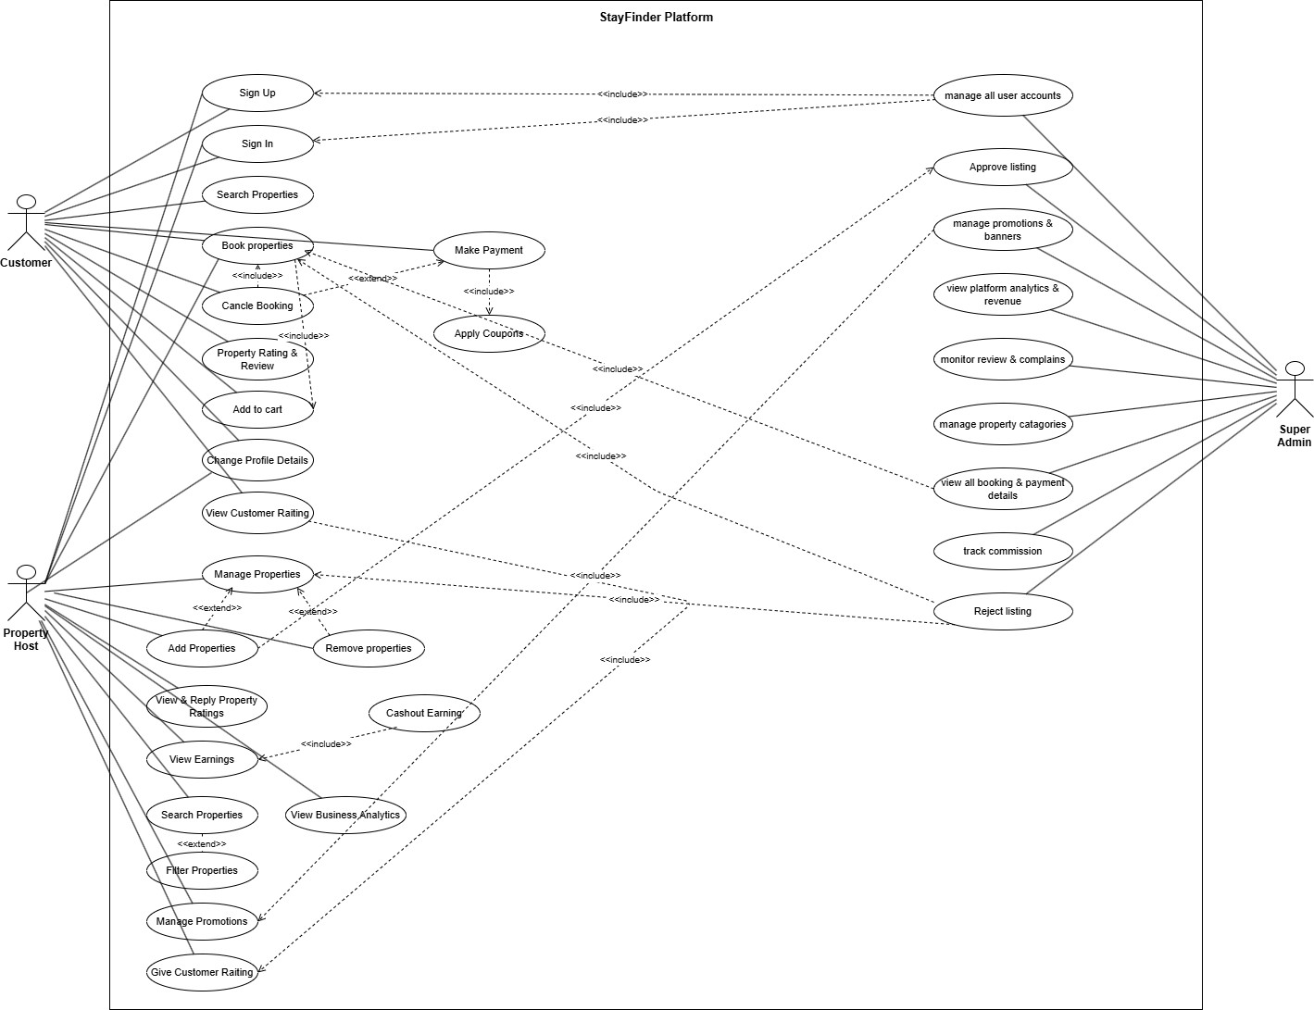

Class diagram:
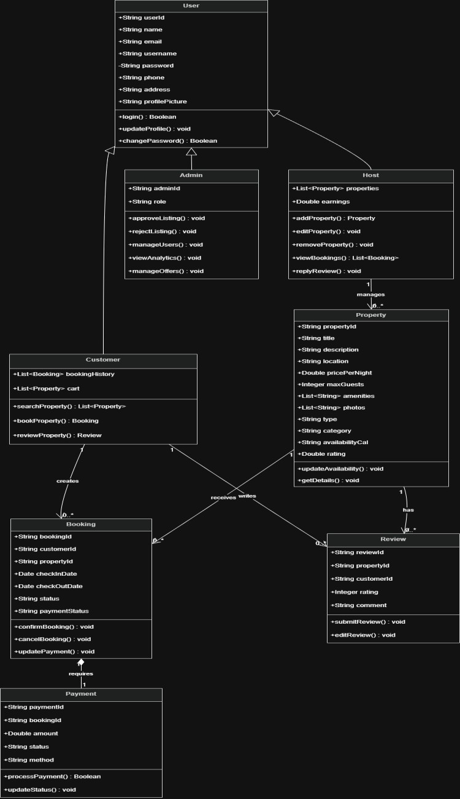

3.1 UI / Wireframe Design using Figma

Search Home:
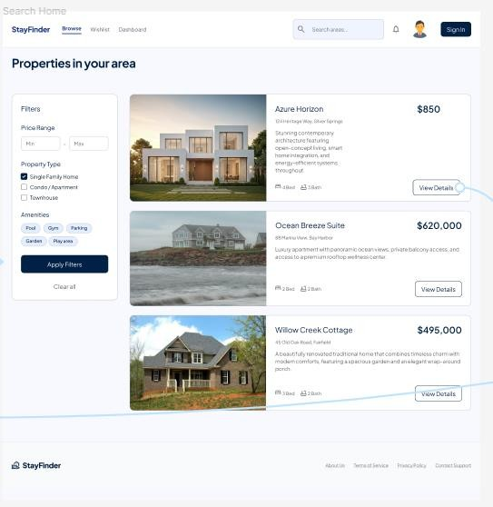

Home:
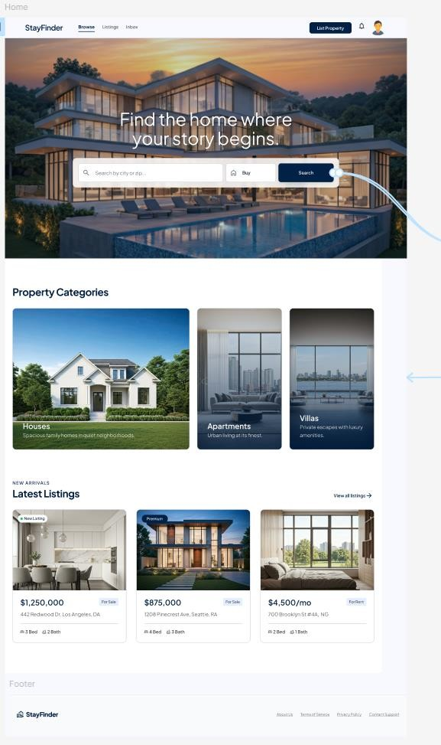

Add property:
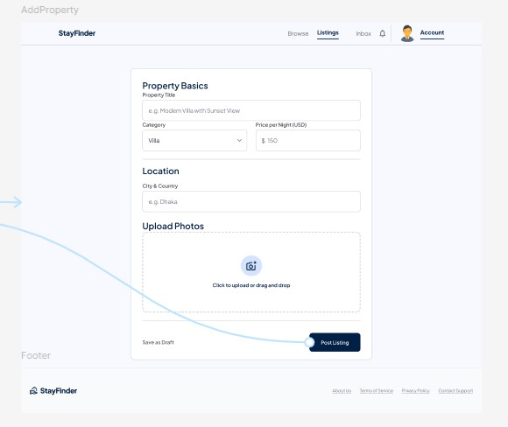

Host Dashboard:
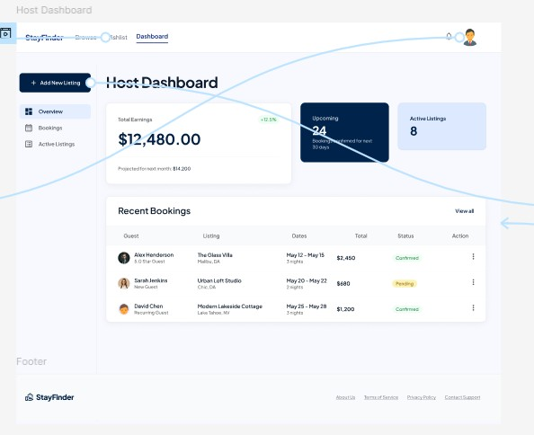

Profile Setting:
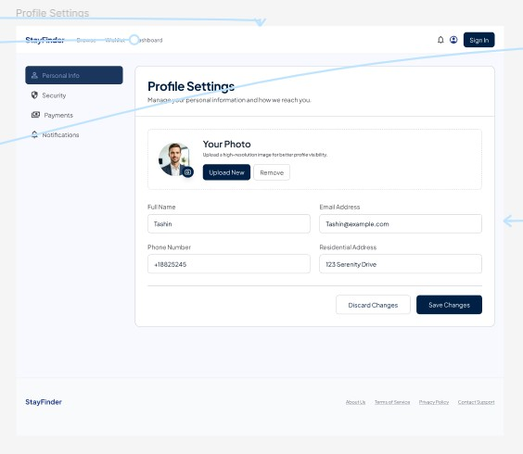

Booking History:

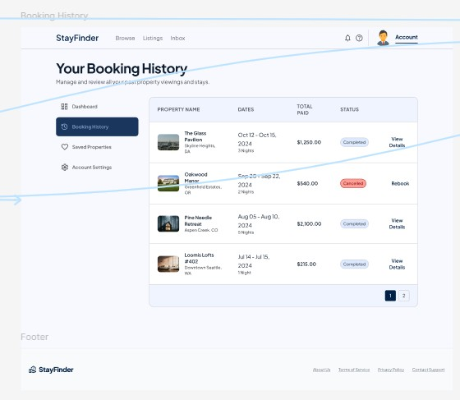

Wishlist:
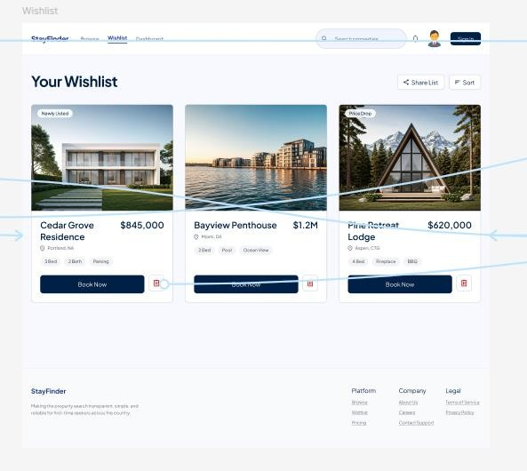

User Dashboard:

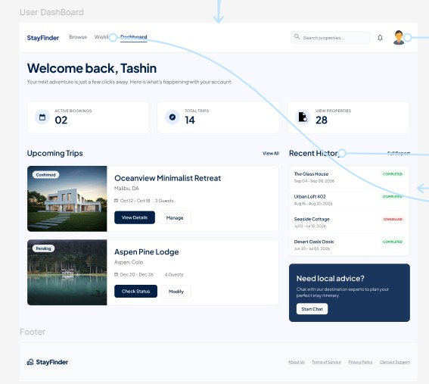

Admin Panel:
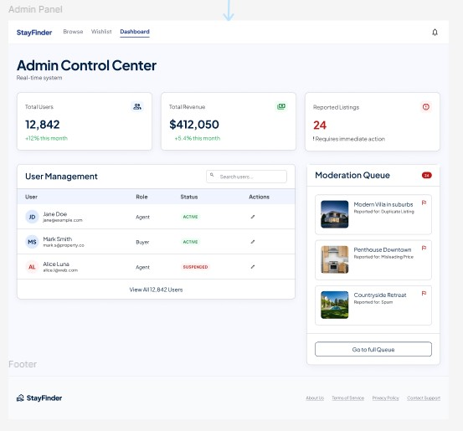
Payment:

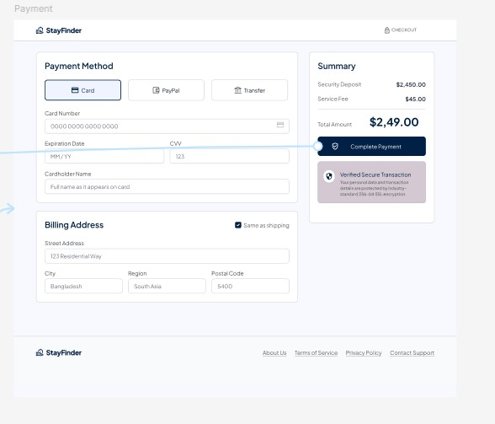

Confirm Booking:
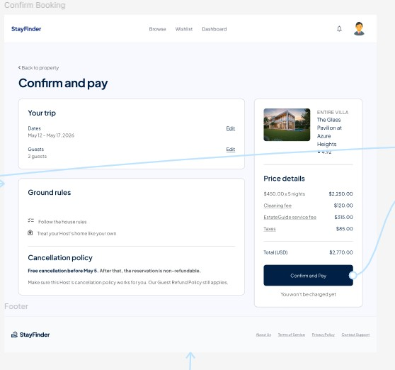

Verify:
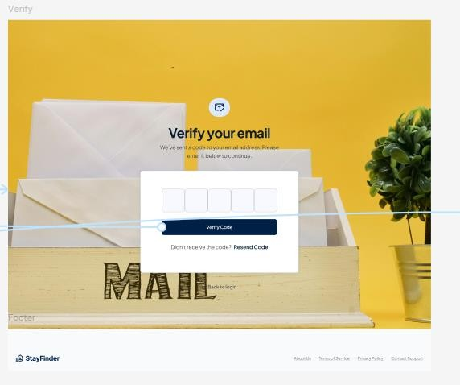

Forget Password:
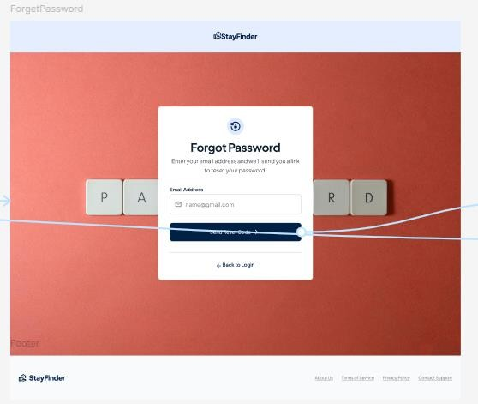

Sign Up:
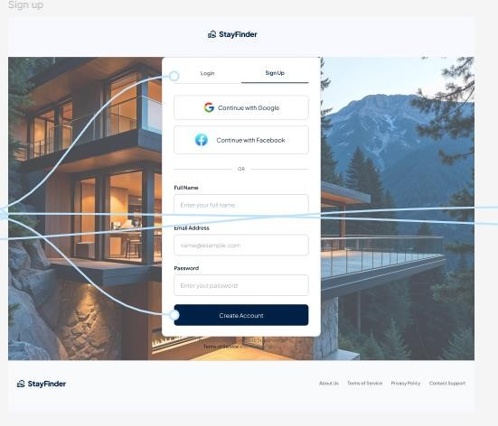

Login:
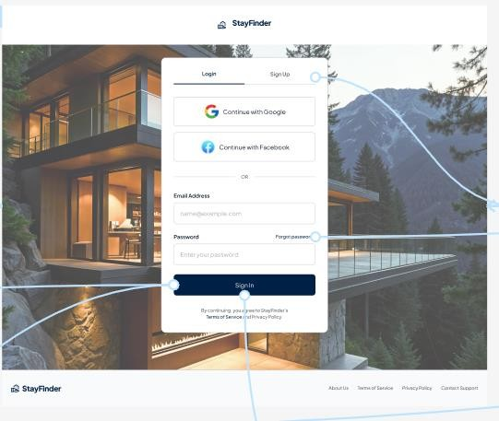

Property Details:
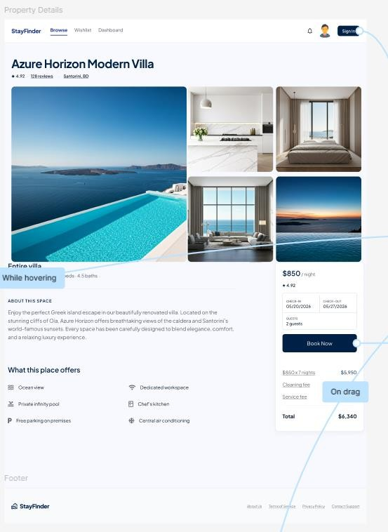

Figma Prototype:
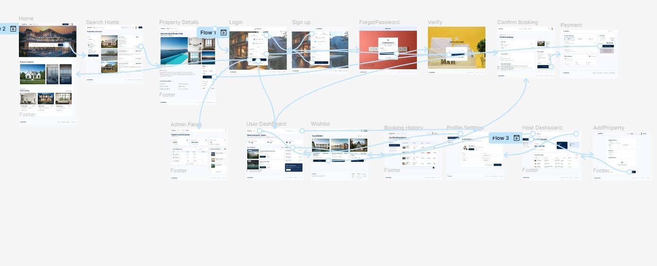
Figma link:
https://www.figma.com/design/YKsKFPxQXpB4jZAmev1jvP/StayFinder?node-id=23469&p=f&t=jfp2dWZIYjOB6ueM-0

5. GIT WORKFLOW

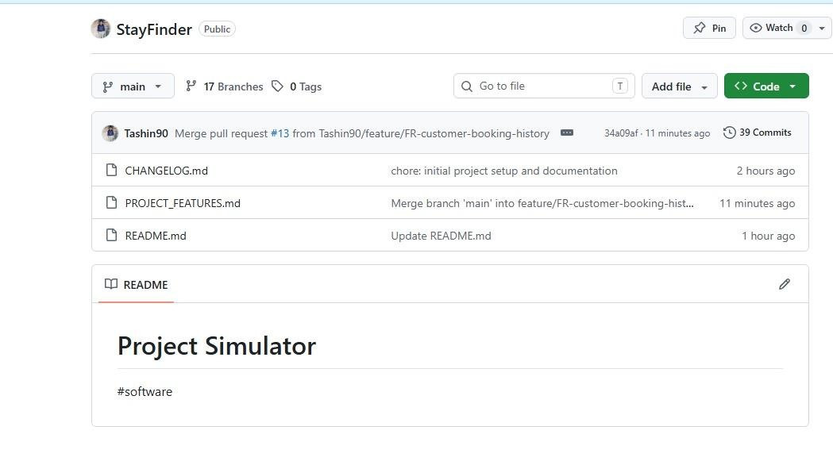
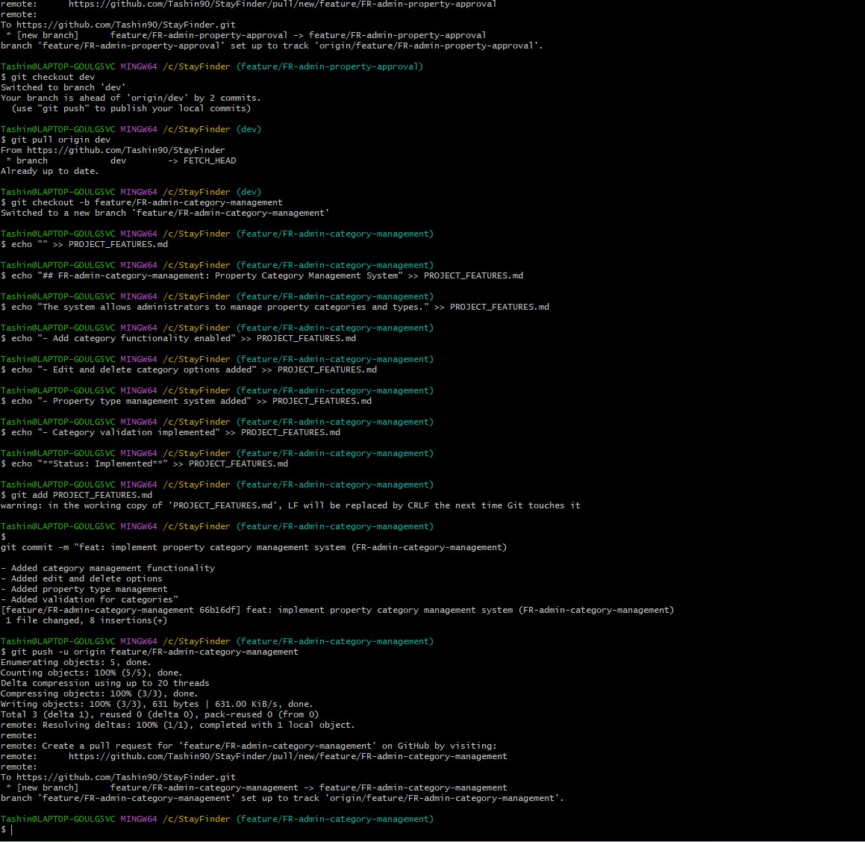
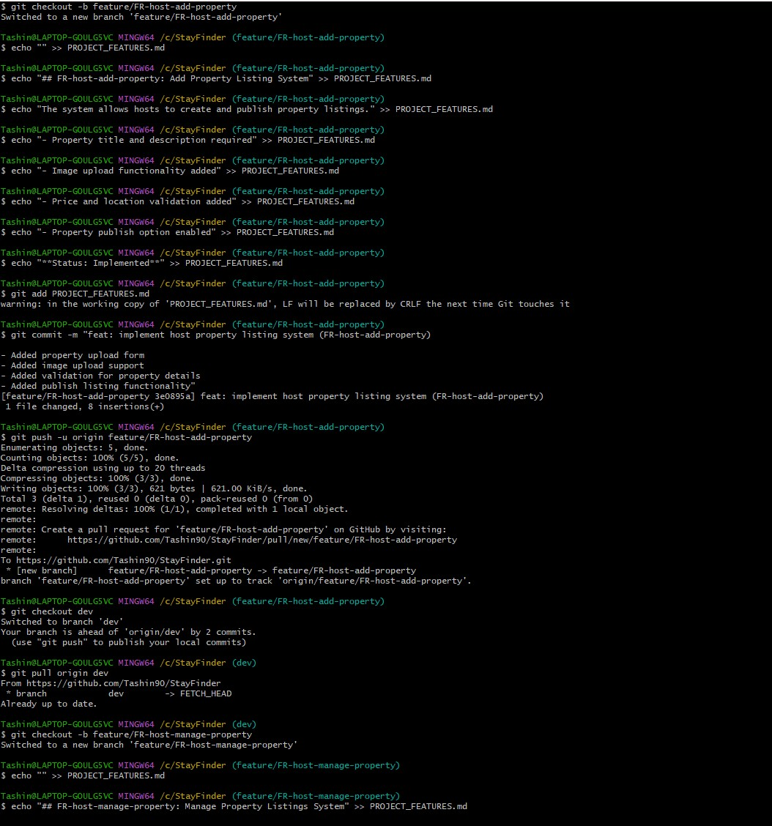
Github link: https://github.com/Tashin90/StayFinder

Trello Board:
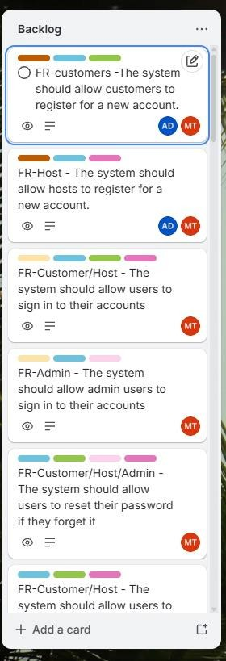

Trello link:
https://trello.com/b/BqPp79V2/stayfinder

6. SOFTWARE TESTING
Test case table of functional requirements
Project Name: Stay  Finder |  | Test Designed by: | Abdullah  Al  Mahbub
Test Case ID:  TC_AUTH_01 |  | Test Designed date: | 17-May-  2026
Test Priority: High |  | Test Executed by:
Module Name: Customer  Registration Module |  | Test Execution date:
Test Title: Verify that a customer can register for a new account
Description: Ensure the system allows a customer to register by filling all required fields, validates email uniqueness, enforces password rules, sends OTP, and redirects to the Customer Dashboard upon successful registration.
Precondition: User is on the Customer Registration page. No existing account with the test email address.
Dependencies: OTP/Email delivery service must be operational; database must be accessible.

Test Steps | Test Data | Expected Results | Actual  Results | Status  (Pass/Fail)

1. Open the Customer Registration page and observe the form fields | N/A | Registration form loads with fields: Full Name, Email,  Username, Password,  Confirm Password, Phone  Number, Address, and a  'Register' button
2. Fill all required fields with valid data and click 'Register' | Full Name: John Doe, Email:  john@test.com,  Username: johndoe, Password: John@1234, Phone:  01700000001,  Address: Dhaka | OTP is sent to the registered phone number; system prompts for OTP entry to complete verification
3. Enter a valid OTP to complete verification | Valid OTP received on phone | OTP is verified successfully; a confirmation email is sent; user is redirected to the  Customer Dashboard
4. Enter an already registered email in the Email field and submit | Email:  john@test.com  (already used) | System displays 'Invalid or already used email' message; form submission is blocked
5. Enter a password with fewer than 8 characters and submit | Password:  Jo@1 | System shows validation error: password must be minimum 8 characters long
6. Enter a Confirm Password that does not match the Password field and submit | Password:  John@1234,  Confirm Password:  John@5678 | System shows 'Password do not match' message; form submission is blocked
7. Submit the registration form leaving the 'Full Name' field empty | Full Name: empty; all other fields filled | System highlights the empty required field and prevents form submission
8. Verify the page footer contains Terms & Conditions and  Privacy Policy links | Observe page footer | Both Terms & Conditions and Privacy Policy links are visible and clickable in the footer

Test case table of functional requirements
Project Name: Stay  Finder |  | Test Designed by: | Abdullah  Al  Mahbub
Test Case ID:  TC_AUTH_02 |  | Test Designed date: | 17-May-  2026
Test Priority: High |  | Test Executed by:
Module Name: Host  Registration Module |  | Test Execution date:
Test Title: Verify that a host can register for a new account
Description: Ensure the system allows a host to register with all mandatory fields, enforces password complexity rules, verifies identity via OTP, displays a success message, and redirects to the Host Dashboard.
Precondition: User is on the Host Registration page. No existing account with the test email address.
Dependencies: OTP/Email verification service must be active; database must be accessible.

Test Steps | Test Data | Expected Results | Actual  Results | Status  (Pass/Fail)

1. Open the Host Registration page and observe form fields | N/A | Form loads with all required fields: Full Name/Business  Name, Email, Username,  Password, Confirm  Password, Phone Number,  Business Address, and a  'Register as Host' button
2. Submit the form leaving a mandatory field empty | Leave  'Business  Address' blank; all other fields filled | System shows appropriate error message for the missing required field; form is not submitted
3. Enter a password without a special character and submit | Password:  HostPass1 | System shows error: password must meet complexity rules (minimum length and at least one special character)
4. Fill all mandatory fields with valid data and click 'Register as  Host' | Business Name: Stay  Villa, Email:  host@test.com,  Password: Host@1234, Phone:  01800000001 | OTP is sent for email/phone verification; system prompts for OTP entry
5. Enter a valid OTP to complete verification | Valid OTP received | Verification succeeds; success message is displayed; user is redirected to the Host Dashboard
6. Enter a duplicate email already registered on the platform and submit | Email:  host@test.com  (already registered) | System shows error for duplicate/invalid input; form is not submitted
7. Verify the Host Dashboard is fully accessible after successful registration | Check page  after redirect | Host Dashboard loads correctly with host name and relevant sections visible
8. Verify the registration page footer contains Terms & Conditions and  Privacy Policy links | Observe page footer | Both links are present and navigable in the page footer

Test case table of functional requirements
Project Name: Stay  Finder |  | Test Designed by: | Abdullah  Al  Mahbub
Test Case ID:  TC_AUTH_03 |  | Test Designed date: | 17-May-  2026
Test Priority: High |  | Test Executed by:
Module Name: User Sign  In Module |  | Test Execution date:
Test Title: Verify that users can sign in to their accounts
Description: Ensure the sign-in page authenticates customers and hosts, redirects each to the correct dashboard, shows error on invalid credentials, and supports Google Sign-In and Remember Me session persistence.
Precondition: At least one active Customer account and one active Host account exist. User is on the Sign In page.
Dependencies: Database must have registered users; Google OAuth must be configured.

Test Steps | Test Data | Expected Results | Actual  Results | Status  (Pass/Fail)
1. Enter valid  Customer credentials and click 'Sign In' | Email:  customer@test.com,  Password:  Cust@1234 | User is redirected to the Customer Dashboard; session is established successfully
2. Enter valid Host credentials and click  'Sign In' | Email:  host@test.com,  Password:  Host@1234 | User is redirected to the Host Dashboard; session is established successfully
3. Enter an incorrect password for a valid email and click 'Sign  In' | Email:  customer@test.com,  Password:  WrongPass | System shows 'Invalid email or password' message; no dashboard redirect occurs
4. Enable  'Remember Me', sign in with valid credentials, close and reopen the browser | Remember Me: checked; Email:  customer@test.com,  Password:  Cust@1234 | User session is retained for 30 days; user remains signed in after reopening the browser
5. Click the 'Sign In with Google' option and complete Google authentication | Valid Google account | Google OAuth popup opens; after successful auth, user is redirected to the appropriate dashboard
6. Leave the Email field blank and click  'Sign In' | Email: empty, Password:  Cust@1234 | System shows a  validation error for the empty email field; form is  not submitted
7. Verify all required elements are present on the Sign In page | Observe Sign In page | Page shows Email field,  Password field,  Remember Me checkbox, Google Sign In button, and Forgot Password link
8. Click the 'Forgot  Password' link | N/A | User is navigated to the  Password Recovery page

Test case table of functional requirements
Project Name: Stay  Finder |  | Test Designed by: | Abdullah  Al  Mahbub
Test Case ID:  TC_AUTH_04 |  | Test Designed date: | 17-May-  2026
Test Priority: High |  | Test Executed by:
Module Name: Admin  Sign In Module |  | Test Execution date:
Test Title: Verify that admin users can sign in to their accounts
Description: Ensure the Admin Sign In page validates @stayfinder.com email domain, matches the password, redirects to Admin Dashboard on success, and locks the account for 15 minutes after 5 consecutive failed attempts.
Precondition: An Admin account with a valid @stayfinder.com email exists. User is on the Admin Sign In page.
Dependencies: Admin accounts must exist in the database; account lockout mechanism must be enabled.

Test Steps | Test Data | Expected Results | Actual  Results | Status  (Pass/Fail)
1. Enter an email not ending with @stayfinder.com  and click 'Sign In' | Email:  admin@gmail.com,  Password:  Admin@1234 | System shows 'Invalid admin email' message; login is blocked
2. Enter a valid @stayfinder.com email with an incorrect password and click 'Sign In' | Email:  admin@stayfinder.com, Password: WrongPass | System shows 'Invalid email or password' message; no dashboard access is granted
3. Fail login 5 consecutive times with wrong credentials | 5 incorrect password attempts for admin@stayfinder.com | Account is locked after the 5th failed attempt; system displays an account lockout message
4. Attempt to sign in immediately after the account is locked | admin@stayfinder.com with any password within 15-minute lockout period | System blocks the login attempt and informs user the account is locked for 15 minutes
5. Wait 15 minutes and sign in with valid admin credentials | Email:  admin@stayfinder.com,  Password:  Admin@1234 (after lockout expires) | Login succeeds; admin is redirected to the  Admin Dashboard
6. Enter valid admin credentials and click  'Sign In' | Email:  admin@stayfinder.com,  Password:  Admin@1234 | Admin is successfully redirected to the Admin Dashboard; session is established
7. Verify the Admin  Sign In page has a 'Forgot Password'  option | Observe the Admin  Sign In page | 'Forgot Password' link is visible and navigable on the page
8. Verify the Admin Dashboard loads completely after successful login | Valid admin credentials | Admin Dashboard renders fully with admin navigation and management sections  visible

Test case table of functional requirements
Project Name: Stay  Finder |  | Test Designed by: | Abdullah  Al  Mahbub
Test Case ID:  TC_AUTH_05 |  | Test Designed date: | 17-May-  2026
Test Priority: High |  | Test Executed by:
Module Name: Password  Reset Module |  | Test Execution date:
Test Title: Verify that users can reset their password if they forget it
Description: Ensure the password reset flow validates the registered email, delivers a time-limited OTP (10 minutes), enforces new password rules (min 8 chars, special character), confirms password match, and redirects to Sign In on success.
Precondition: A registered user account exists. User is on the Forgot Password / Password Recovery page.
Dependencies: Email OTP delivery service must be functional.

Test Steps | Test Data | Expected Results | Actual  Results | Status  (Pass/Fail)
1. Enter an unregistered email and click 'Send OTP' | Email: noone@test.com | System shows 'No account found' message;  OTP is not sent
2. Enter a valid registered email and click 'Send OTP' | Email: customer@test.com | OTP is sent to the registered email address; OTP input field appears on screen
3. Enter the received OTP within 10 minutes and proceed | Valid OTP from email | OTP is accepted; user is allowed to set a new password
4. Enter an OTP after the 10-minute validity window has expired | Expired OTP | System shows OTP expired message; user must request a new OTP to proceed
5. Enter a new password shorter than 8 characters | New Password: Pass1! | System shows error: new password must be minimum 8 characters long
6. Enter a new password without any special character | New Password:  Password1 | System shows error: new password must contain at least one special character
7. Enter a  mismatching Confirm Password and attempt to reset | New Password:  NewPass@1,  Confirm Password:  NewPass@2 | System shows 'Password do not match' message; password reset is blocked
8. Complete password reset with all valid inputs | Valid OTP, New Password:  NewPass@1,  Confirm Password:  NewPass@1 | System shows 'Password reset successful' message and redirects user to the  Sign In page

Test case table of functional requirements
Project Name: Stay  Finder |  | Test Designed by: | Fariha  Mahafuz  Medha
Test Case ID:  TC_AUTH_06 |  | Test Designed date: | 17-May-  2026
Test Priority: Medium |  | Test Executed by:
Module Name: User  Profile Management  Module |  | Test Execution date:
Test Title: Verify that users can view and edit their profile information
Description: Ensure the profile page pre-fills all existing fields, validates email format and phone number length, restricts photo uploads to PNG/JPG within 2MB, verifies old password on change, and shows a success notification upon saving.
Precondition: User is logged in as Customer or Host and has navigated to the Profile page.
Dependencies: User profile data must exist in the database.

Test Steps | Test Data | Expected Results | Actual  Results | Status  (Pass/Fail)
1. Navigate to the Profile page and observe all fields | N/A | All existing profile fields (Full  Name, Email, Phone, Date of Birth, Address, Profile Photo) are pre-filled with current data
2. Edit the Full Name field and click 'Save  Changes' | Full Name:  Jane Doe | Success notification is displayed; profile page is refreshed showing the updated name
3. Enter an invalid email format and click  'Save Changes' | Email:  janedoe#test | System shows email format validation error; changes are  not saved
4. Enter a phone number with fewer than  11 digits and click  'Save Changes' | Phone: 01700 | System shows phone number validation error indicating 11 digits are required
5. Upload a profile photo in PNG format within 2MB and save | File:  photo.png, Size: 1.5MB | Photo is uploaded and displayed on the profile; success notification is shown
6. Attempt to upload a profile photo larger  than 2MB | File:  bigphoto.jpg, Size: 5MB | System shows error:  maximum file size is 2MB; the photo is rejected and not uploaded
7. Attempt to change password with an incorrect old password | Old  Password:  WrongOld,  New  Password:  NewPass@1 | System shows error: old password is incorrect; password is not updated
8. Attempt to upload a profile photo in an unsupported format | File: image.gif | System shows error: only PNG/JPG formats are  accepted; the file is not uploaded
9. Change password with correct old password and a valid new password | Old  Password:  Cust@1234,  New  Password:  NewPass@1  (8+ chars) | Password is updated successfully; success notification is displayed

Test case table of functional requirements
Project Name: Stay  Finder |  | Test Designed by: | Fariha  Mahafuz  Medha
Test Case ID:  TC_PROP_01 |  | Test Designed date: | 17-May-  2026
Test Priority: High |  | Test Executed by:
Module Name: Property  Listing Management  Module |  | Test Execution date:
Test Title: Verify that hosts can add new property listings
Description: Ensure a host can submit a property listing with all required fields and at least one valid photo, that price must be a positive number, and the listing is saved with 'Pending Approval' status with host notification on admin action.
Precondition: Host is logged in and has navigated to the Add Property Listing page.
Dependencies: Host account must be active; admin approval workflow must be in place.

Test Steps | Test Data | Expected Results | Actual  Results | Status  (Pass/Fail)
1. Fill all required fields and upload one valid photo, then click 'Submit Listing' | Title: Sea  View Villa,  Price: 5000, Location:  Cox's Bazar,  Type: Villa, Category: Luxury, Photo:  room.jpg (3MB) | Listing is saved with status 'Pending Approval'; host sees a confirmation message
2. Submit listing without uploading any photo | All required fields filled; no photo uploaded | System shows error: minimum  1 photo is required; listing is not submitted
3. Upload a photo exceeding 5MB | Photo:  largeroom.jpg,  Size: 8MB | System shows error: each photo must not exceed 5MB; the photo is rejected
4. Enter a negative value in the Price field and submit | Price: -500 | System shows validation error: price must be a positive number; listing is not submitted
5. Verify listing is not visible in customer search before admin approval | Search for  'Sea View  Villa' as a  Customer | Listing is not visible in customer-facing search results while status is 'Pending Approval'
6. Have admin approve the listing and verify host receives a notification | Admin approves  listing from Admin Panel | Host receives a notification (email/in-app) confirming that the listing has been approved
7. Have admin reject the listing and verify host receives notification with reason | Admin rejects listing with reason: 'Incomplete images' | Host receives a notification with the rejection reason provided by the admin
8. Verify the listing form contains all required fields including Amenities and Availability | Observe  listing creation form | Form includes: Property Title,  Description, Type, Category,  Price Per Night, Location,  Photos, Amenities, and  Availability fields

Test case table of functional requirements
Project Name: Stay  Finder |  | Test Designed by: | Fariha  Mahafuz  Medha
Test Case ID:  TC_PROP_02 |  | Test Designed date: | 17-May-  2026
Test Priority: High |  | Test Executed by:
Module Name: Property  Listing Edit & Removal  Module |  | Test Execution date:
Test Title: Verify that hosts can edit or remove their property listings
Description: Ensure the host can view all listings with status, edit listing data (resetting status to Pending Approval), see a confirmation before removal, and have removed listings disappear from customer search immediately.
Precondition: Host is logged in with at least one existing property listing. Host is on the Property Management page.
Dependencies: Active and pending property listings must exist for the host.

Test Steps | Test Data | Expected Results | Actual  Results | Status  (Pass/Fail)
1. Navigate to the  Property Management page and observe all listings | N/A | All host listings are displayed with their current status: Active, Pending, or Rejected
2. Click 'Edit' on an active listing, update the Title, and click  'Save Changes' | New Title:  Updated Sea  View Villa | Edit form is pre-filled with existing data; after saving, listing status changes to 'Pending Approval' and a success message is shown
3. Verify that editing a listing resets its status to 'Pending Approval' | Edit any active listing | After saving edits, listing status becomes 'Pending Approval' — not Active
4. Click 'Remove  Listing' for a selected listing | Any existing listing | Confirmation dialog appears before removal action is executed
5. Confirm the removal in the confirmation dialog | Click 'Confirm' on the dialog | Listing is removed; it no longer appears in customer
 |  | property search results immediately
6. Verify the edit form is pre-filled with all existing data | Open edit form for any listing | All fields — Title, Description,  Type, Category, Price,  Location, Photos, Amenities — are pre-populated with  current data
7. Cancel the removal confirmation dialog | Click 'Cancel' on the confirmation dialog | Listing is not removed; it remains in the host's listing table unchanged
8. Verify a rejected listing is visible in the host's listing table with  correct status | Check  rejected listing in Property Management | Rejected listing appears with status 'Rejected' in the host's  Property Management page

Test case table of functional requirements
Project Name: Stay  Finder |  | Test Designed by: | Fariha  Mahafuz  Medha
Test Case ID:  TC_PROP_03 |  | Test Designed date: | 17-May-  2026
Test Priority: High |  | Test Executed by:
Module Name: Property  Approval Module |  | Test Execution date:
Test Title: Verify that administrators can approve or reject property listings
Description: Ensure the admin can view all pending listings, approve or reject them with a mandatory rejection reason, that the host is notified in both cases, and approved listings appear immediately in customer search.
Precondition: Admin is logged in. At least one property listing is in 'Pending Approval' status.
Dependencies: Host-submitted listings with Pending status must exist; email notification service must be active.

Test Steps | Test Data | Expected Results | Actual  Results | Status  (Pass/Fail)
1. Navigate to the Pending Listings page and observe the listing table | N/A | All pending listings are shown with listing information and host information; filter options are visible
2. Click 'Approve' on a pending listing and confirm | Any pending  listing | Listing status changes to 'Active'; host receives an email notification about the approval
3. Verify the approved listing appears immediately in customer-facing property search | Search for approved  listing as a  Customer | Approved listing is visible in customer search results immediately after approval
4. Click 'Reject' on a pending listing, enter a rejection reason, and confirm | Rejection Reason: 'Incomplete property images' | Listing is rejected; host receives an email notification that includes the rejection reason provided
5. Attempt to reject a listing without entering a rejection reason | Rejection reason field:  empty | System prevents rejection; prompts admin to provide a rejection reason before proceeding
6. Apply the Status filter to show only Pending listings | Filter: Status  = Pending | Table updates to display only listings with Pending status
7. Apply the Category filter on the listings table | Filter:  Category =  Luxury | Table updates to show only  Luxury category listings
8. Apply the Date filter to narrow listings by submission date | Filter: Date = current week | Table shows only listings submitted within the selected date range

Test case table of functional requirements
Project Name: Stay  Finder |  | Test Designed by: | Fariha  Mahafuz  Medha
Test Case ID:  TC_PROP_04 |  | Test Designed date: | 17-May-  2026
Test Priority: Medium |  | Test Executed by:
Module Name: Property  Category & Type  Management Module |  | Test Execution date:
Test Title: Verify that administrators can manage property categories and types
Description: Ensure the admin can add, edit, and delete property categories and types, that changes are reflected in listing forms and search filters, and that duplicate names are rejected.
Precondition: Admin is logged in and has navigated to the Category and Type Management page.
Dependencies: Property listing form and customer search filter must consume categories/types from the database.

Test Steps | Test Data | Expected Results | Actual  Results | Status  (Pass/Fail)
1. Click 'Add  Category', enter a new category name, and save | Category  Name: Eco-  Friendly | New category is added to the category list successfully; no error is shown
2. Attempt to add a category with a name that already exists | Category  Name: Luxury (already exists) | System shows error: duplicate category name is not allowed; category is not added
3. Edit an existing category name and save | Category:  Eco-Friendly  → Eco Stay | Category is updated in the list; the updated name is reflected in the host listing form and customer search filters
4. Delete an unused category and verify it is removed | Category: Eco Stay (no listings assigned) | Category is removed from the list; it no longer appears in listing forms or search filters
5. Add a new Property Type and verify it appears in the host listing form | Type: Cabin | New type 'Cabin' is selectable in the Property Type dropdown on the host listing form
6. Verify updated categories are reflected in the customer-facing search filters | Open customer property search filters | Updated categories and types appear correctly in the customer-facing search filter options
7. Attempt to add a property type with a duplicate name | Type: Hotel (already exists) | System shows error: duplicate type name is not allowed; type is not added
8. Delete an existing property type and verify it is removed from search filters | Type: Cabin | Cabin type is removed from the list and no longer shown in customer search filter options

Test case table of functional requirements
Project Name: Stay  Finder |  | Test Designed by: | Argho  Dey
Test Case ID:  TC_SRCH_01 |  | Test Designed date: | 17-May-  2026
Test Priority: High |  | Test Executed by:
Module Name: Property  Search & Filter Module |  | Test Execution date:
Test Title: Verify that customers can search and filter properties
Description: Ensure the search page allows filtering by location, dates, guest count, price, category, type, amenities, and ratings; updates results dynamically; supports sorting; and shows a no-result message when no properties match.
Precondition: Customer is logged in. Multiple approved property listings with varied types, categories, and amenities exist.
Dependencies: Approved listings with varied attributes must exist in the system.

Test Steps | Test Data | Expected Results | Actual  Results | Status  (Pass/Fail)
1. Enter a location, check-in/check-out dates, and guest count, then click 'Search' | Location:  Cox's Bazar,  Check-in: next  Friday, Check-out: +3 days, Guests:  2 | Search results display matching property cards with image, price, rating, and location for the given criteria
2. Apply the Price Range filter and observe results | Price Range:  2000 – 5000  BDT | Results update dynamically to show only properties within the specified price range
3. Apply the Property  Type filter — select  'Villa' | Type: Villa | Results update to show only Villa-type properties; other property types are hidden
4. Apply the Ratings filter — select 4 stars  and above | Rating: 4+ | Results update to show only properties rated 4 stars or higher
5. Sort results by  'Price: Low to High' | Sort: Price  Low to High | Properties are reordered from lowest to highest price per night
6. Search with criteria that match no available properties | Location:  Remote  Island X | System shows a 'No properties match your criteria' message; no blank page or error is displayed
7. Apply the Amenities filter — select 'WiFi' | Amenity: WiFi | Results update to show only properties that include WiFi in their amenities
8. Verify results update dynamically without a full page reload after applying a filter | Apply any  filter | Search results update on the same page without requiring a full page reload

Test case table of functional requirements
Project Name: Stay  Finder |  | Test Designed by: | Argho  Dey
Test Case ID:  TC_SRCH_02 |  | Test Designed date: | 17-May-  2026
Test Priority: High |  | Test Executed by:
Module Name: Property  Details Module |  | Test Execution date:
Test Title: Verify that customers can view full property details
Description: Ensure the property detail page shows complete information including photos, amenities, availability calendar, host info, ratings and reviews, and allows the customer to proceed to booking or add to cart.
Precondition: Customer is logged in. At least one approved property with images, amenities, and reviews exists.
Dependencies: Approved properties with complete data (photos, reviews, host info) must be in the system.

Test Steps | Test Data | Expected Results | Actual  Results | Status  (Pass/Fail)
1. Click on any property card from search results | Any approved property | Property detail page loads displaying: title, images/gallery, price per night, type, category, location, and description
2. Verify the Amenities section is displayed on the detail page | N/A | Amenities list (e.g., WiFi, AC, Parking) is visible for the selected property
3. Check the  Availability Calendar for a range of dates | Select checkin and checkout dates | Calendar displays available and unavailable dates; user can determine if selected dates are open
4. Verify the Ratings and Reviews section is | N/A | Customer reviews with star ratings and comments are
present on the detail page |  | displayed in the Reviews section
5. Verify Host Information is shown on the property detail page | N/A | Host name and relevant host information are visible on the property detail page
6. Click the 'Book Now' button | N/A | User is navigated to the booking/checkout flow for the selected property
7. Click the 'Add to  Cart' button | N/A | Property is added to the cart; a success notification is shown; cart item count updates in navigation
8. Verify the property image gallery is navigable | Click through property images | Images are navigable  (next/previous); the gallery loads without error

Test case table of functional requirements
Project Name: Stay  Finder |  | Test Designed by: | Argho  Dey
Test Case ID:  TC_SRCH_03 |  | Test Designed date: | 17-May-  2026
Test Priority: Medium |  | Test Executed by:
Module Name: Offers &  Discounts Module |  | Test Execution date:
Test Title: Verify that customers can view offers and apply promo codes
Description: Ensure the Offers page displays all available offers with relevant details, allows promo code application, validates codes before applying, updates booking price on valid codes, and shows an error for invalid or expired codes.
Precondition: Customer is logged in. At least one valid and one expired promo code exist in the system.
Dependencies: Active and expired promo codes must be configured in the system.

Test Steps | Test Data | Expected Results | Actual  Results | Status  (Pass/Fail)
1. Navigate to the Offers & Discounts page | N/A | Page loads with a list of available offers showing: image, title, discount %, and validity date for each offer
2. View the details of any single offer | Click on any offer card | Offer details are shown: discount amount, validity period, and applicable conditions
3. Apply a valid promo code in the promo code input field | Promo Code:  STAY20 | Promo code is validated successfully; discount is applied; booking price updates to reflect the discount
4. Apply an invalid promo code | Promo Code:  WRONGCODE | System shows an error message for the invalid promo code; no discount is applied
5. Apply an expired promo code | Promo Code:  EXPIRED10 | System shows an error indicating the offer has expired; no discount is applied
6. Verify booking price updates correctly after | Promo Code:  STAY20 (20% | Booking summary reflects the correctly discounted price
applying a valid promo code | off); Total:  5000 BDT | (4000 BDT) after applying the code
7. Verify the Featured Deals section is visible on the page | Observe page layout | Highlighted featured deal cards are present and visible on the Offers & Discounts page
8. Verify offers are grouped into categories on the page | Observe offer categories | Offers are organized into categories: Seasonal Offers,  Promo Codes, and Special  Packages

Test case table of functional requirements
Project Name: Stay  Finder |  | Test Designed by: | Argho  Dey
Test Case ID:  TC_BOOK_01 |  | Test Designed date: | 17-May-  2026
Test Priority: High |  | Test Executed by:
Module Name: Cart  Management Module |  | Test Execution date:
Test Title: Verify that customers can manage their cart
Description: Ensure the customer can add properties to the cart, view all cart items with pricing, remove individual items, apply promo codes from the cart, and proceed to checkout.
Precondition: Customer is logged in. At least one approved property is available for booking.
Dependencies: Approved property listings must be available; promo code service must be functional.

Test Steps | Test Data | Expected Results | Actual  Results | Status  (Pass/Fail)
1. Add a property to the cart from its detail page and navigate to the Cart page | Any approved property with dates selected | Cart page loads showing the added property with name, dates, guests, and price breakdown
2. Add multiple properties to the cart and verify the cart displays all items | Add 2–3  different properties | All added properties are displayed in the cart with individual prices and a total price summary
3. Remove one property from the cart | Remove one  cart item | Property is removed from the cart; cart updates immediately; total price adjusts accordingly
4. Apply a valid promo code from the cart page | Promo Code:  STAY20 | Promo code is validated; total cart price is updated to reflect the discount
5. Apply an invalid or expired promo code from the cart | Promo Code:  INVALID99 | System shows an error message for the invalid/expired code; cart total  remains unchanged
6. Click 'Proceed to  Checkout' from the cart page | N/A | User is navigated to the booking/payment page with the selected cart items prefilled
7. Verify the cart is accessible from the main navigation bar | Click cart icon from any page | Cart page or dropdown is accessible from any page on the platform via the navigation bar
8. Verify the cart item count in the navigation updates after adding a property | Add one property to an empty cart | Cart icon in the navigation bar updates to show a count of 1

Test case table of functional requirements
Project Name: Stay  Finder |  | Test Designed by: | Argho  Dey
Test Case ID:  TC_BOOK_02 |  | Test Designed date: | 17-May-  2026
Test Priority: High |  | Test Executed by:
Module Name: Booking &  Partial Payment Module |  | Test Execution date:
Test Title: Verify that customers can create a booking with partial payment
Description: Ensure the system allows a customer to book a property by paying a partial amount, calculates and displays the remaining balance, confirms booking with 'Partial Paid' status, and stores the booking in history.
Precondition: Customer is logged in and has selected a property to book. Payment gateway is configured.
Dependencies: Active property listings must be available; payment gateway integration must be functional.

Test Steps | Test Data | Expected Results | Actual  Results | Status  (Pass/Fail)
1. Proceed to the booking page for a selected property and observe the payment section | Property: Sea View Villa, Dates: selected | Booking summary clearly shows total price, partial payment amount (e.g., 30%), and remaining balance
2. Verify that partial  payment amount and remaining balance calculations are accurate | Total Price:  10,000 BDT;  Partial: 30% | Partial amount is shown as 3,000 BDT and remaining balance as 7,000 BDT
3. Select a payment method and click 'Pay  Partial Amount' | Payment Method: bKash | Partial payment is processed; booking is confirmed with status 'Partial Paid'; confirmation message is displayed
4. Verify the booking appears in Booking  History with 'Partial  Paid' status | Navigate to  Booking  History | Booking is listed with correct property name, dates, and  'Partial Paid' status
5. Verify the remaining balance is visible in the  booking details | Open the booking detail view | Remaining balance amount is clearly shown in booking details and booking history
6. Verify the system allows the customer to complete the remaining payment before checkin | Navigate to partially paid booking in Booking  History | 'Pay Remaining Amount' option is available and visible for the partially paid booking
7. Attempt to proceed to payment without selecting a payment method | Payment method: none selected | System shows a validation error; payment cannot proceed without a payment method selected
8. Verify booking status is visible as 'Partial Paid' in the admin panel | Check booking in admin Booking  Oversight | Admin can see the booking listed with 'Partial Paid' status in the booking overview

Test case table of functional requirements
Project Name: Stay  Finder |  | Test Designed by: | MD.  Naimul  Haque
Test Case ID:  TC_BOOK_03 |  | Test Designed date: | 17-May-  2026
Test Priority: High |  | Test Executed by:
Module Name: Remaining  Payment Module |  | Test Execution date:
Test Title: Verify that customers can complete the remaining payment for a booking
Description: Ensure the system displays remaining balance for partial-paid bookings, processes the remaining payment, updates status to 'Fully Paid', sends a confirmation notification, and prevents overpayment or duplicate payment.
Precondition: Customer is logged in with at least one booking in 'Partial Paid' status.
Dependencies: A partially paid booking must exist; payment gateway must be functional.

Test Steps | Test Data | Expected Results | Actual  Results | Status  (Pass/Fail)
1. Navigate to Booking  History and open a  'Partial Paid' booking | Booking  Status: Partial  Paid | Booking detail page shows: paid amount, remaining balance, and 'Pay Remaining  Amount' button
2. Click 'Pay  Remaining Amount', select a payment method, and confirm | Payment  Method: Card; Remaining Balance:  7,000 BDT | Remaining payment is processed; booking status updates to 'Fully Paid'; payment confirmation notification is generated
3. Verify booking history is updated to 'Fully Paid' status after payment | Check  Booking  History after full payment | Booking record shows 'Fully Paid' status with an updated payment summary
4. Verify a payment confirmation notification is received after completing full payment | Complete remaining payment | Email or in-app notification is sent confirming full payment and updated booking status
5. Attempt to pay an amount greater than the remaining balance | Enter amount:  9,000 BDT (remaining balance is 7,000 BDT) | System blocks the transaction; shows error: amount exceeds remaining balance
6. Attempt duplicate payment on a 'Fully  Paid' booking | Try to pay again on an already fully paid booking | 'Pay Remaining Amount' button is disabled or hidden for fully paid bookings; duplicate payment is prevented
7. Verify the payment method selection is available on the remaining payment page | Observe the remaining payment page | At least one payment method option is displayed and selectable on the payment page
8. Verify the booking detail page clearly shows payment status | Open any booking in Booking  History | Payment status (Partial Paid / Fully Paid) is clearly labelled in the booking detail view

Test case table of functional requirements
Project Name: Stay  Finder |  | Test Designed by: | MD.  Naimul  Haque
Test Case ID:  TC_BOOK_04 |  | Test Designed date: | 17-May-  2026
Test Priority: Medium |  | Test Executed by:
Module Name: Booking  History Module |  | Test Execution date:
Test Title: Verify that customers can view their booking history
Description: Ensure the Booking History page lists all bookings categorized as past and upcoming, displays property name, dates, price, payment status, booking status, and supports filtering/sorting and detail view.
Precondition: Customer is logged in with at least one past and one upcoming booking.
Dependencies: Completed and upcoming bookings must exist for the test customer account.

Test Steps | Test Data | Expected Results | Actual  Results | Status  (Pass/Fail)
1. Navigate to the  Booking History page | N/A | Page loads showing a list of all customer bookings with: property name, dates, price, payment status, and booking status
2. Verify bookings are categorized into 'Past Bookings' and  'Upcoming Bookings' | Observe page sections | Separate sections or tabs for past and upcoming bookings are clearly visible on the page
3. Verify payment status is displayed for each booking entry | Observe the booking list | Each booking entry shows payment status: Partial Paid or Fully Paid
4. Click 'View Details' for any booking | Any existing booking | Booking detail view opens with complete information:  property, dates, price, booking status, and payment summary
5. Apply filter by Status  — select 'Upcoming' | Filter: Status  = Upcoming | Booking list updates to show only upcoming bookings
6. Sort bookings by date — most recent  first | Sort: Date  Descending | Booking list reorders to display the most recent bookings at the top
7. Verify the Booking History page is accessible from the customer dashboard navigation | Navigate from  Customer  Dashboard | Booking History is reachable directly from the customer dashboard or navigation  menu
8. Verify all required columns are visible in the booking history table | Observe the booking table | Table shows columns:  Property Name, Dates, Price,  Payment Status, Booking  Status, and Actions

Test case table of functional requirements
Project Name: Stay  Finder |  | Test Designed by: | MD.  Naimul  Haque
Test Case ID:  TC_REV_01 |  | Test Designed date: | 17-May-  2026
Test Priority: Medium |  | Test Executed by:
Module Name: Customer  Review Submission  Module |  | Test Execution date:
Test Title: Verify that customers can submit a property review
Description: Ensure a customer who completed a stay can submit a star rating and required review text, optionally upload images, and receive a confirmation message upon successful submission.
Precondition: Customer is logged in with at least one completed (past) booking for a property.
Dependencies: A completed booking must exist; review submission module must be active.

Test Steps | Test Data | Expected Results | Actual  Results | Status  (Pass/Fail)
1. Navigate to the  Submit Review page for a completed booking | Property: Sea  View Villa (completed stay) | Review form loads with: property name auto-filled, 1–  5 star rating selector, comment/review text box, and optional image upload field
2. Submit the review without entering any comment text | Rating: 3 stars, Comment:  empty | System shows validation error: review text is required; submission is blocked
3. Submit the review without selecting any star rating | Rating: none, Comment:  'Good place' | System shows validation error: star rating is required; submission is blocked
4. Select a star rating, enter review text, and click 'Submit Review' | Rating: 4 stars, Comment:  'Great stay, very clean!' | Review is submitted successfully; confirmation message is displayed after  submission
5. Submit review with an optional image attached | Image:  room_photo.jpg (2MB), Rating:  5, Comment:  'Excellent!' | Review with image is submitted; confirmation message shown; review appears on property page
6. Submit review without uploading any image | No image,  Rating: 4,  Comment:  'Nice property' | Review is submitted successfully without an image; image upload field is confirmed as optional
7. Verify the submitted review appears on the property detail page | Navigate to the reviewed property as any user | Review with rating, comment, and customer name is displayed in the Reviews section
8. Verify the star rating selector allows values from 1 to 5 | Observe the rating control on the review form | Rating selector allows selection of 1, 2, 3, 4, or 5 stars

Test case table of functional requirements
Project Name: Stay  Finder |  | Test Designed by: | MD.  Naimul  Haque
Test Case ID:  TC_REV_02 |  | Test Designed date: | 17-May-  2026
Test Priority: Medium |  | Test Executed by:
Module Name: Host  Review Response Module |  | Test Execution date:
Test Title: Verify that hosts can reply to customer reviews
Description: Ensure the host can view all customer reviews, submit a reply, edit or delete that reply, and have all changes reflected instantly under the original review.
Precondition: Host is logged in. At least one customer review exists for the host's property.
Dependencies: At least one approved customer review must be present for a host-owned property.

Test Steps | Test Data | Expected Results | Actual  Results | Status  (Pass/Fail)
1. Navigate to the Review Responses page and observe the review list | N/A | All customer reviews are displayed with: Customer Name, Rating, Review Text, Date, and a Reply Box under each review
2. Type a reply in the reply box for a review and click 'Submit Reply' | Reply: 'Thank you for your feedback!' | Reply is submitted and displayed immediately under the original customer review
3. Verify the reply is displayed instantly below the original review without page reload | Observe after submitting the reply | Reply appears under the customer's review immediately; no full page reload is required
4. Click 'Edit Reply' on a previously submitted reply and update the content | Updated Reply: 'We appreciate your kind words!' | Reply content is updated; changes are reflected immediately on the review list
5. Click 'Delete Reply' on an existing reply and confirm deletion | Any existing host reply | Reply is removed; the review section updates without the deleted reply
6. Verify a customer can see the host's reply under their review on the property page | View property detail page as a customer | Host reply is displayed beneath the customer's review on the public property detail page
7. Submit a blank reply (no text entered) for a review | Reply text:  empty | System shows a validation error; blank reply is not submitted
8. Verify the host can view reviews from all owned properties on the same page | Host with 2+ properties | Reviews from all host-owned properties are visible together on the Review Responses page

Test case table of functional requirements
Project Name: Stay  Finder |  | Test Designed by: | MD.  Naimul  Haque
Test Case ID:  TC_REV_03 |  | Test Designed date: | 17-May-  2026
Test Priority: High |  | Test Executed by:
Module Name: Admin  Review Moderation  Module |  | Test Execution date:
Test Title: Verify that admin can perform review moderation
Description: Ensure the admin can view all submitted reviews, approve or reject them with immediate status update, delete inappropriate reviews, and that only approved reviews are visible to users.
Precondition: Admin is logged in. Reviews with Pending, Approved, and Rejected statuses exist in the system.
Dependencies: Customer-submitted reviews in various statuses must exist in the system.

Test Steps | Test Data | Expected Results | Actual  Results | Status  (Pass/Fail)
1. Navigate to the Review Moderation | N/A | Table displays all reviews with: Review ID, User Name,  Property Name, Rating,
page and observe the review table |  | Comment, and Status  (Pending/Approved/Rejected); filter options are visible
2. Click 'Approve' on a  Pending review | Any Pending review | Review status changes to 'Approved'; the review becomes visible to customers on the property page
3. Click 'Reject' on a  Pending review | Any Pending review | Review status changes to 'Rejected'; the review is not visible to customers
4. Verify only  Approved reviews are visible on the property detail page for customers | View property page as a Customer | Only reviews with 'Approved' status are shown; Pending and Rejected reviews are hidden from public view
5. Click 'Delete Review' on an inappropriate review | Any review  (any status) | Review is permanently deleted and no longer appears in the admin review moderation table
6. Apply the Status filter — select 'Pending' | Filter: Status  = Pending | Table updates to show only reviews with Pending status
7. Verify the review status label updates immediately after an approval or rejection action | Approve a Pending review | Review status label changes from 'Pending' to 'Approved' instantly without requiring a page reload
8. Apply the Date filter to narrow down reviews by submission date | Filter: Date = last 7 days | Table shows only reviews submitted within the selected date range

7. CONCLUSION
In this project, StayFinder is designed as a comprehensive travel stay platform designed to bridge the gap between travelers and property owners. StayFinder’s benefits include providing customers with affordable, reliable accommodations through secure payments, while offering hosts robust tools to manage listings and track earnings.
Throughout the documentation, we established clear project scopes covering profile, user, booking, and property management. We developed detailed user stories and a comprehensive Requirement Traceability Matrix to ensure all functional requirements for customers, hosts, and super admins are met. The workflow integrated industry-standard practices, including Git for version control, Trello for task management, and Figma for the intuitive UI/UX design.
In the future, we aim to expand the platform by integrating AI-driven personalized recommendations and advanced analytics for hosts. By maintaining these high standards of software engineering, StayFinder is well-positioned to become a reliable, centralized solution for the modern travel industry.

